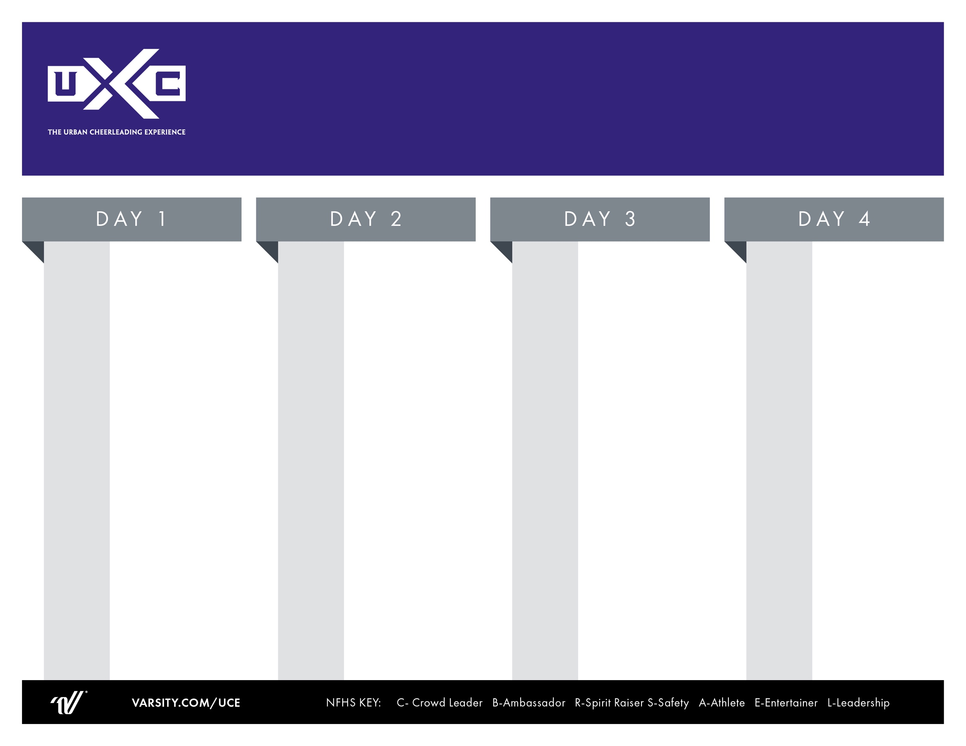
Overnight Cheer Camp
Breakfast

Warm Up

Mentor Meeting

Doors Open

Game Day Live
Final Performances
Final Awards
7:00 AM

9:00 AM

9:15 AM

9:45 AM

10:00 AM

11:00 AM

Breakfast
Warm Up
Game Day Live
Cheer & Chants Class
***Coaches Meeting
HOMECOMING: Game Day Routine
Pyramid Class
“U-Tine” PCH Prep
Lunch

Purple: U”Tine PCH
Silver: Hip Hop Part 2

ROTATE

T.U.C.E All-American

Beyond U: (A/E)

Dinner

Open Practice

“U-Tine”Evals

Ready, Set, Cheer Live Rally

Material Review/Daily Awards
Breakfast
Jump “U”
Game Day Live
Cheer & Chants Class
***Coaches Meeting
Band Dance Dynamics

Stunt Class #2
Cheer PCH Prep
Lunch

Purple: Cheer PCH
Silver: Hip Hop Part 1

ROTATE

Cheer Live:
Performance Counts
Beyond U: (C/R/L)

Dinner

Open Practice

Cheer Evals

U” Jump Championship

Material Review/Daily Awards
7:00 AM
8:45 AM
9:00 AM

9:45 AM

10:30 AM

11:15 AM

11:30 AM

1:30 PM

2:30PM

3:30 PM

4:15 PM

4:30 PM

6:30 PM

6:45 PM

7:15 PM

7:45 PM
7:00 AM
8:30 AM
9:00 AM

9:45 AM

10:30 AM

11:15 AM

11:30 AM

1:30 PM

2:30PM

3:30 PM

4:00 PM

4:30 PM

6:30 PM

6:45 PM

7:15 PM

7:45 PM
9:00 AM

12:00 PM

1:00 PM

1:30 PM

2:15PM

3:00 PM

3:15 PM

4:15 PM

4:30 PM

6:30 PM

7:00 PM

7:30 PM

7:45 PM

8:00 PM

8:15 PM

8:30 PM

Registration Opens

Registration Closes

“Cheer Live” Opening Demo

Game Day Live
Cheer & Chants Class
***Coaches Meeting
“U-Tine”
Pep Rally Routine
***Coaches Meeting

Safety Awareness:
Squad Credentialing (S)
Stunt Class #1
Mentor Meeting w/ Coaches
Dinner

Home Routine Evals
*Show us what you got!
Sideline PCH

Mentor Meeting
Beyond U: (B) – St. Jude Awards
Material Review

Daily Awards

