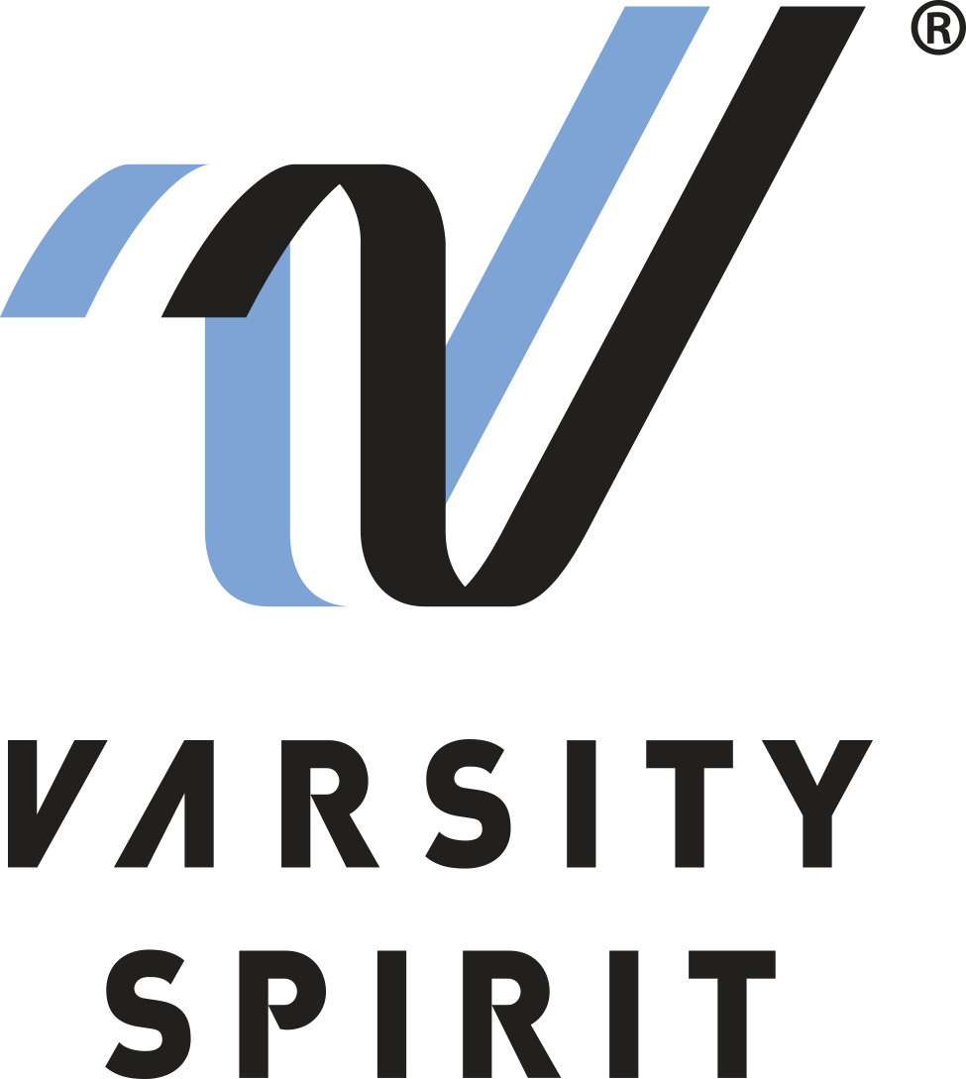
FOR IMMEDIATE RELEASE:

Contact:
Catherine Morris
Varsity Spirit Special Events
(800) 238-0286 ext. 5816
cmorris@varsity.com
www.varsity.com

LOCAL CHEERLEADER/DANCER TO PERFORM IN THANKSGIVING DAY PARADE AT THE WALT DISNEY WORLD® RESORT

Memphis, TN – [Name______________________________________] from [School Name _____________________] in [City, State _____________________] is one of more than 800 elementary, junior high and high school cheerleaders and dancers from across the country that will represent Varsity Spirit in the 2023 Thanksgiving Tour at the Walt Disney World® Resort in Orlando, Florida.

The individuals invited to perform are part of a select group of cheerleaders and dancers chosen as All-Americans during Varsity Spirit summer camps across the country. All-Americans are selected via tryout based on either superior cheerleading or dance skills at camps operated by Universal Cheerleaders Association (UCA), Universal Dance Association (UDA), National Cheerleaders Association (NCA), National Dance Alliance (NDA), or Urban Cheerleading Experience (UCE). Only the top 15% of the cheerleaders and dancers from Varsity Spirit camps earn the chance to march in a holiday parade of this caliber.

[Name ___________________] will perform with the Varsity Spirit All-Americans in a one-of-a-kind performance through Disney’s Magic Kingdom® Park on during Thanksgiving week. Besides enjoying a sunny trip to Orlando, All-Americans will have the opportunity to meet cheerleaders and dancers from across the nation and enjoy a magical holiday season at Walt Disney World® Resort parks.

[Insert quote from All-American here, explaining what they are most looking forward to, or how they feel about being named an All-American.]

The Varsity All-American program is celebrating more than 30 years of choosing camp standouts. For more information, visit www.varsity.com or contact Catherine Morris at
(800) 238-0286 or cmorris@varsity.com.

About Varsity Spirit
Memphis-based Varsity Spirit, the driving force behind cheerleading’s dynamic transformation into the high-energy, athletic activity it is today, is the leading global source for all things spirit, including cheerleading, dance team and performing arts. A division of Varsity Brands, Varsity Spirit is a leader in uniform innovation, as well as educational camps, clinics and competitions, impacting more than a million athletes each year. Focused on safety, entertainment and traditional school leadership, Varsity Spirit’s employees have been dedicated to celebrating spirit through its brands since 1974. For more information about Varsity Spirit or Varsity Brands, please visit varsity.com or varsitybrands.com.

