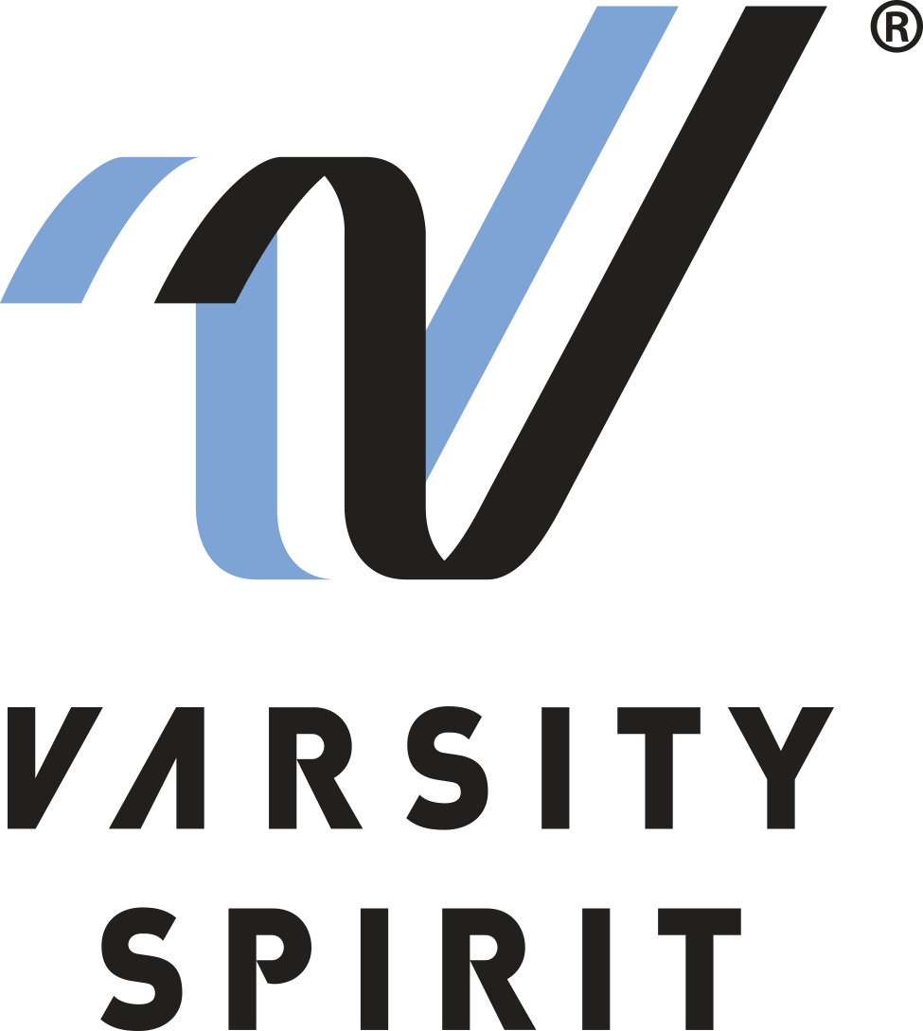
Contact:
Catherine Morris
Varsity Spirit Special Events
(800) 238-0286 ext. 5816
cmorris@varsity.com

Local Mascots to Perform at the VRBO citrus bowl
Local resident is one of an elite number of Mascots chosen to perform in Bowl Game.

Memphis, Tenn., (Date) – [Name ________________________________] from [High School name ____________________] in [City, State___________________] is one of more than 50 All-American Mascots from across the country who will perform in the Cheez-It Citrus Bowl in Orlando, Florida on January 1, 2024.

The individuals invited to perform in the half-time performance are Mascot All-Americans from Universal Cheerleaders Association (UCA) and National Cheerleaders Association (NCA) summer camps, two brands under the Varsity Spirit umbrella. All-Americans are selected via tryout based on their overall character development and crowd leading skills. Only the top 10% of the mascots attending UCA or NCA camps earn the chance to perform in this year’s Bowl.

Mascots will travel along with cheerleading and dance team members to Orlando for a week of rehearsals dedicated to preparing them for their Citrus Bowl half-time performance, where they will perform in front of 60,000 fans in the Camping World Stadium in Orlando, Florida.

This unique opportunity for mascots is an excellent way to celebrate the New Year. The Citrus Bowl has been a college football tradition since 1947. The game gives cheerleaders and dancers the opportunity to perform at the 7th oldest collegiate bowl in the country, as well as the opportunity to visit Universal Studios Orlando.

For more information, visit www.varsity.com or contact Catherine Morris with Varsity Spirit at (800) 238-0286 ext. 5816 or cmorris@varsity.com.

About Varsity Spirit
Memphis-based Varsity Spirit, the driving force behind cheerleading’s dynamic transformation into the high-energy, athletic activity it is today, is the leading global source for all things spirit, including cheerleading, dance team and performing arts. A division of Varsity Brands, Varsity Spirit is a leader in uniform innovation, as well as educational camps, clinics and competitions, impacting more than a million athletes each year. Focused on safety, entertainment and traditional school leadership, Varsity Spirit’s employees have been dedicated to celebrating spirit through its brands since 1974. For more information about Varsity Spirit or Varsity Brands, please visit varsity.com or varsitybrands.com.

