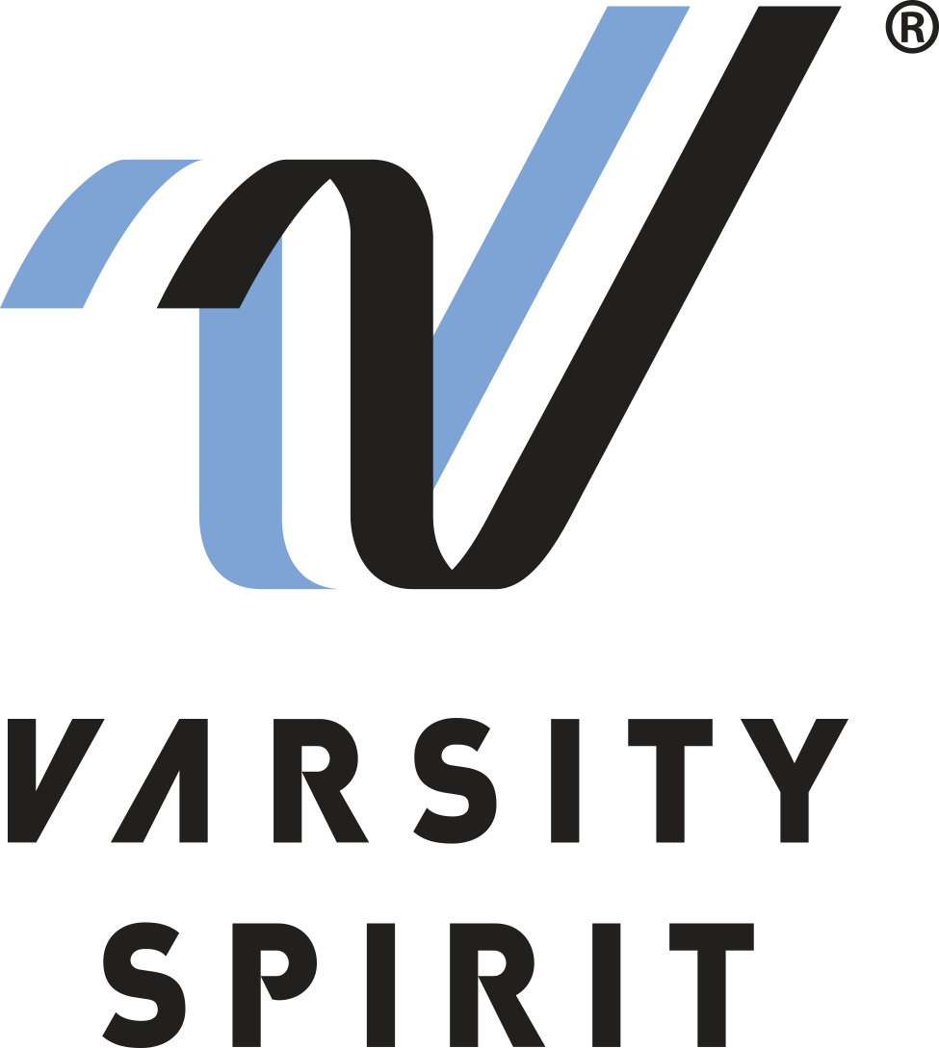
FOR IMMEDIATE RELEASE:

Catherine Morris
Varsity Spirit Special Events
(800) 238-0286 ext. 5816
cmorris@varsity.com

LOCAL HIGH SCHOOL TEAM INVITED TO PERFORM AT THE
CHEEZ-IT CITRUS BOWL IN ORLANDO

Memphis, TN – (date) The [School Name __________________] cheerleaders/dancers from [City, State ________________] will be performing in the Cheez-It Citrus Bowl in Orlando, Florida on January 1, 2024.

The teams invited to perform in the pre-game performance are trophy winners from Universal Cheerleaders Association (UCA), Universal Dance Association (UDA), National Cheerleaders Association (NCA), National Dance Alliance (NDA) summer camps and Urban Cheerleading Experience (UCE) brands under the Varsity Spirit umbrella.

Team members will travel as a team to Orlando for a week of rehearsals dedicated to preparing them for their Citrus Bowl half-time performance. The dancers and cheerleaders will perform in front of 60,000 fans at this popular college football game in the Camping World Stadium in Orlando, Florida.

The Citrus Bowl has been a college football tradition since 1947. The game gives cheerleaders and dancers the opportunity to perform at the 7th oldest collegiate bowl in the country, as well as the opportunity to visit Universal Studios Orlando.

For more information, visit www.varsity.com or contact Catherine Morris at (800) 238-0286 x 5816 or cmorris@varsity.com.

About Varsity Spirit
Memphis-based Varsity Spirit, the driving force behind cheerleading’s dynamic transformation into the high-energy, athletic activity it is today, is the leading global source for all things spirit, including cheerleading, dance team and performing arts. A division of Varsity Brands, Varsity Spirit is a leader in uniform innovation, as well as educational camps, clinics and competitions, impacting more than a million athletes each year. Focused on safety, entertainment and traditional school leadership, Varsity Spirit’s employees have been dedicated to celebrating spirit through its brands since 1974. For more information about Varsity Spirit or Varsity Brands, please visit varsity.com or varsitybrands.com.

