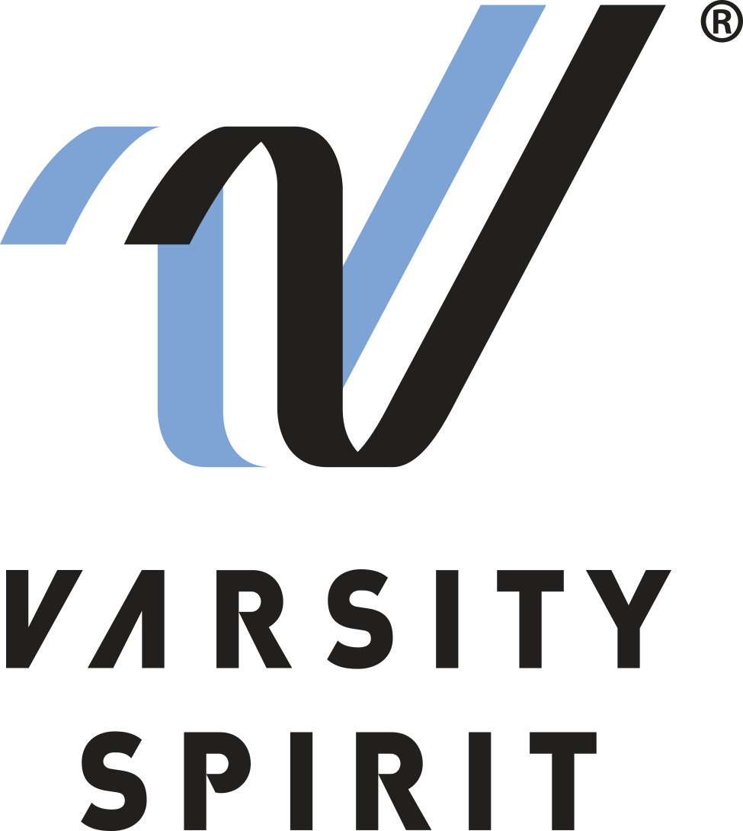
FOR IMMEDIATE RELEASE:

Press Release: This is an example of a press release. Simply add your details to the bracketed sections (delete the brackets), and any additional information that makes this experience unique. Contact to your local news outlets (newspaper, radio stations) in your area with a good, clear photo of the athlete.
(Note – search your city, state “local news outlets” in google, and follow the steps to submit content. This may vary from news outlet to news outlet.)
Within the release below, there is a space for you to add your own quote. Please do not change any text that is not within brackets. Delete this paragraph before sending.

Contact:
John Calitri
Varsity Spirit Special Events
844-399-0644
jcalitri@varsity.com
www.varsity.com

LOCAL CHEERLEADER/DANCER TO PERFORM IN THE VARSITY SPIRIT SPECTACULAR AT THE WALT DISNEY WORLD® RESORT

Memphis, TN – [Name______________________________________] from [School Name _____________________] in [City, State _____________________] is one of more than 800 high school cheerleaders and dancers from across the country that will represent the camp brands of Varsity Spirit in the Varsity Spirit Spectacular at the Walt Disney World® Resort in Orlando, Florida from November 17 - November 20, 2023.

The individuals invited to perform are part of a select group of captains, co-captains, officers and seniors who attended a Varsity Spirit summer camp this summer hosted by Universal Cheerleaders Association (UCA), Universal Dance Association (UDA), National Cheerleaders Association (NCA), National Dance Alliance (NDA), United Spirit Association (USA) and Urban Cheerleading Experience (UCE).

[Name ___________________] will perform in an exclusive performance at Disney’s Magic Kingdom Park before of hundreds of fans. Besides enjoying a sunny trip to Orlando, performers will have the opportunity to meet cheerleaders and dancers from across that nation and enjoy a magical holiday season at Walt Disney World® Resort parks.

[Insert quote from participant here, explaining what they are most looking forward to, or how they feel about being a part of the Varsity Spirit Spectacular.]

For more information, visit www.varsity.com or contact John Calitri at jcalitri@varsity.com.

About Varsity Spirit
Memphis-based Varsity Spirit, the driving force behind cheerleading’s dynamic transformation into the high-energy, athletic activity it is today, is the leading global source for all things spirit, including cheerleading, dance team and performing arts. A division of Varsity Brands, Varsity Spirit is a leader in uniform innovation, as well as educational camps, clinics and competitions, impacting more than a million athletes each year. Focused on safety, entertainment and traditional school leadership, Varsity Spirit’s employees have been dedicated to celebrating spirit through its brands since 1974. For more information about Varsity Spirit or Varsity Brands, please visit varsity.com or varsitybrands.com.

