FOR IMMEDIATE RELEASE:

Press Release: This is an example of a press release. Simply add your details to the bracketed sections (delete the brackets), and any additional information that makes this experience unique. Contact to your local news outlets (newspaper, radio stations) in your area with a good, clear photo of the athletes/team.
(Note – search your city, state “local news outlets” in google, and follow the steps to submit content. This may vary from news outlet to news outlet.)
Within the release below, there is a space for you to add your own quote. Please do not change any text that is not within brackets. Delete this paragraph before sending.

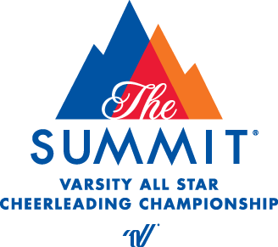
PRESS RELEASE
Contact: Melanie Berry
Varsity Spirit Special Events
mberry@varsity.com

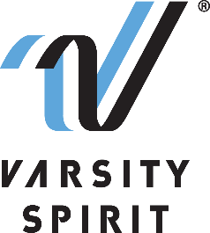

LOCAL HIGH SCHOOL [CHEERLEADING/DANCE TEAM/MASCOT] INVITED TO PERFORM AT THE VRBO CITRUS BOWL IN ORLANDO, FL

[Your city, state, date] – [School Name] is proud to announce that its [cheerleading/dance team/mascot], will represent Varsity Spirit, the global leader in cheerleading, dance team and band apparel, camps and competitions, and a division of Varsity Brands, the market leader in team sports, school spirit and achievement recognition, in the VRBO Citrus Bowl Pre-Game Performance at the Universal Orlando Resort on December 30, 2022 – January 3, 2023.

Cheerleaders, dancers, and mascots who are invited to perform in the VRBO Citrus Bowl Pre-Game Performance are part of a select group of trophy-winning squads and teams and All-Americans identified at Varsity Spirit summer camps across the country. Trophy-winning teams and All-Americans are based on superior cheerleading or dance skills as well as leadership skills at camps operated by Universal Cheerleaders Association (UCA), Universal Dance Association (UDA), National Cheerleaders Association (NCA), National Dance Alliance (NDA), United Spirit Association (USA) or Urban Cheerleading Experience (UCE). [School Name/Mascot Name] attended [UCA/UDA/NCA/NDA/USA/UCE Camp] at [Camp Location] on [Camp Dates] where [He/She/They] was/were selected for this experience.

“We are thrilled that these excellent athletes will have the chance to perform and experience our Special Events in Orlando, FL,” said Bill Seely, President of Varsity Spirit. “We are honored to provide them a one-of-a-kind opportunity, where they will meet and connect with cheerleaders, dancers and mascots from across the country, and create memorable experiences at the Universal Orlando Resort parks.”

[Name of School/Athlete/Mascot] will perform with the Varsity Spirit Trophy Winners and All-Americans in a one-of-a-kind pre-game performance. Besides enjoying a sunny trip to Orlando, athletes will have the opportunity to meet cheerleaders, dancers, and mascots from across the nation and enjoy a memorable holiday season at the Universal Orlando Resort parks.

[Insert quote from school/athlete/mascot here, explaining what he/she/they are most looking forward to, or how they feel about this experience.]

Varsity Spirit is celebrating more than 30 years of honoring camp standouts. For more information, visit VRBO Citrus Bowl.

About Varsity Spirit
Memphis-based Varsity Spirit, the driving force behind cheerleading’s dynamic transformation into the high-energy, athletic activity it is today, is the leading global source for all things spirit, including cheerleading, dance team and performing arts. A division of Varsity Brands, Varsity Spirit is a leader in uniform innovation, as well as educational camps, clinics and competitions, impacting more than a million athletes each year. Focused on safety, entertainment and leadership, Varsity Spirit’s employees have been dedicated to celebrating spirit through its brands since 1974. For more information about Varsity Spirit or Varsity Brands, please visit varsity.com or varsitybrands.com.

