FOR IMMEDIATE RELEASE:

Press Release: This is an example of a press release. Simply add your details to the bracketed sections (delete the brackets), and any additional information that makes this experience unique. Contact to your local news outlets (newspaper, radio stations) in your area with a good, clear photo of the athlete.
(Note – search your city, state “local news outlets” in google, and follow the steps to submit content. This may vary from news outlet to news outlet.)
Within the release below, there is a space for you to add your own quote. Please do not change any text that is not within brackets. Delete this paragraph before sending.

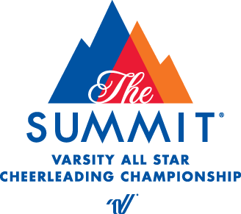
PRESS RELEASE
Catherine Morris
Varsity Spirit Special Events
cmorris@varsity.com

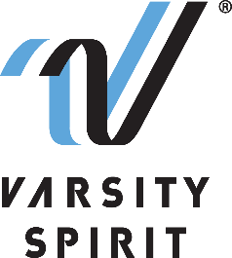

LOCAL [CHEERLEADER/DANCER] TO PERFORM AT THE PHILADELPHIA THANKSGIVING DAY PARADE

[Your city, state, date] – [School Name] is proud to announce that a member of its [cheerleading/dance] team, [Name of athlete], will represent Varsity Spirit, the global leader in cheerleading, dance team and band apparel, camps and competitions, and a division of Varsity Brands, the market leader in team sports, school spirit and achievement recognition, in the 102nd Annual Philadelphia Thanksgiving Day Parade in Philadelphia, PA on November 22-25, 2022.

Cheerleaders and dancers who are invited to perform in the Philadelphia Thanksgiving Day Parade are part of a select group of All-Americans identified at Varsity Spirit summer camps across the country. All-Americans are based on either superior cheerleading or dance skills at camps operated by Universal Cheerleaders Association (UCA), Universal Dance Association (UDA), National Cheerleaders Association (NCA), National Dance Alliance (NDA), or Urban Cheerleading Experience (UCE). [School Name] attended [UCA/UDA/NCA/NDA/UCE Camp] at [Camp Location] on [Camp Dates] where [He/She/They] was selected as an All-American. Only the top 12% of the cheerleaders and dancers from Varsity Spirit camps earn the chance to participate in a performance of this caliber.

“We are thrilled that these excellent athletes will have the chance to perform and experience our Special Events in Philadelphia, PA,” said Bill Seely, President of Varsity Spirit. “We are honored to provide them a one-of-a-kind opportunity, where they will meet and connect with cheerleaders, dancers from across the country, and create memorable experiences in the historic city of Philadelphia.”

[Name of athlete] will perform with the Varsity Spirit All-Americans in a one-of-a-kind performance at the Philadelphia Thanksgiving Day Parade. Besides enjoying a memorable trip to Philadelphia, All-Americans will have the opportunity to meet cheerleaders and dancers from across the nation and enjoy a magical holiday season in one of the nation’s oldest cities.

[Insert quote from All-American here, explaining what they are most looking forward to, or how they feel about being named an All-American.]

The Varsity Spirit All-American program is celebrating more than 30 years of honoring camp standouts. For more information, visit philadelphia.varsity.com

About Varsity Spirit
Memphis-based Varsity Spirit, the driving force behind cheerleading’s dynamic transformation into the high-energy, athletic activity it is today, is the leading global source for all things spirit, including cheerleading, dance team and performing arts. A division of Varsity Brands, Varsity Spirit is a leader in uniform innovation, as well as educational camps, clinics and competitions, impacting more than a million athletes each year. Focused on safety, entertainment and leadership, Varsity Spirit’s employees have been dedicated to celebrating spirit through its brands since 1974. For more information about Varsity Spirit or Varsity Brands, please visit varsity.com or varsitybrands.com.

