FOR IMMEDIATE RELEASE:

Press Release: This is an example of a press release. Simply add your details to the bracketed sections (delete the brackets), and any additional information that makes this experience unique. Contact to your local news outlets (newspaper, radio stations) in your area with a good, clear photo of the athlete.
(Note – search your city, state “local news outlets” in google, and follow the steps to submit content. This may vary from news outlet to news outlet.)
Within the release below, there is a space for you to add your own quote. Please do not change any text that is not within brackets. Delete this paragraph before sending.

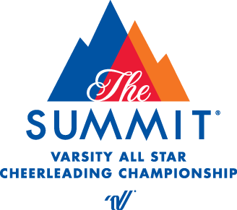
PRESS RELEASE
Contact: John Calitri
Varsity Spirit Special Events
jcalitri@varsity.com

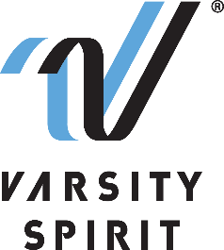

LOCAL HIGH SCHOOL [CHEERLEADER/DANCER] TO PERFORM IN THE PEARL HARBOR MEMORIAL PARADE IN HONOLULU, HI

[Your city, state, date] – [School Name] is proud to announce that its [cheerleading/dance team] member, [Name of athlete], will represent Varsity Spirit, the global leader in cheerleading, dance team and band apparel, camps and competitions, and a division of Varsity Brands, the market leader in team sports, school spirit and achievement recognition, in the Pearl Harbor Memorial Parade at the In Honolulu, HI from December 4-9, 2022.

Cheerleaders and dancers who are invited to perform in the Pearl Harbor Memorial Parade are part of a select group of All-Americans identified at Varsity Spirit summer camps across the country. All-Americans are based on superior cheerleading or dance skills as well as leadership skills at camps operated by Universal Cheerleaders Association (UCA), Universal Dance Association (UDA), National Cheerleaders Association (NCA), National Dance Alliance (NDA), United Spirit Association (USA) or Urban Cheerleading Experience (UCE). [School Name/Mascot Name] attended [UCA/UDA/NCA/NDA/USA/UCE Camp] at [Camp Location] on [Camp Dates] where [He/She/They] was selected as an All-American. Only the top 12% of the cheerleaders and dancers from Varsity Spirit camps earn the chance to participate in a performance of this caliber.
“We are thrilled that these excellent athletes will have the chance to perform and experience our Special Events in Honolulu, HI,” said Bill Seely, President of Varsity Spirit. “We are honored to provide them a one-of-a-kind opportunity, where they will meet and connect with cheerleaders and dancers from across the country, as well as be a part of a meaningful parade experience that represents our nation’s history.”

[Name of Athlete] will perform with Varsity Spirit All-Americans in an exclusive performance prior to the opening ceremony of the parade, and then be a part of the parade before thousands of fans lining the streets of Waikiki Beach. This trip marks the 81st Anniversary of the attack on Pearl Harbor. The parade theme is "remembering the past and celebrating our future." We honor our veterans and their families while recognizing that once bitter enemies can become loyal friends and allies.

Besides being able to perform for true national heroes, athletes will have the opportunity to meet cheerleaders and dancers from across that nation and enjoy a memorable trip to the Pearl Harbor Memorial and the USS Missouri Battleship.

[Insert quote from participant here, explaining what they are most looking forward to, or how they feel about being a part of the Varsity Pearl Harbor Memorial Parade.]

The Varsity Spirit All-American program is celebrating more than 30 years of honoring camp standouts. For more information, visit Varsity Spirit Pearl Harbor Parade in Hawaii.

About Varsity Spirit
Memphis-based Varsity Spirit, the driving force behind cheerleading’s dynamic transformation into the high-energy, athletic activity it is today, is the leading global source for all things spirit, including cheerleading, dance team and performing arts. A division of Varsity Brands, Varsity Spirit is a leader in uniform innovation, as well as educational camps, clinics and competitions, impacting more than a million athletes each year. Focused on safety, entertainment and leadership, Varsity Spirit’s employees have been dedicated to celebrating spirit through its brands since 1974. For more information about Varsity Spirit or Varsity Brands, please visit varsity.com or varsitybrands.com.

