FOR IMMEDIATE RELEASE:

Press Release: This is an example of a press release. Simply add your details to the bracketed sections (delete the brackets), and any additional information that makes this experience unique. Contact your local news outlets (newspaper, radio stations) in your area with a good, clear photo of the athlete.
(Note – search your city, state “local news outlets” in google, and follow the steps to submit content. This may vary from news outlet to news outlet.)
Within the release below, there is a space for you to add your own quote. Please do not change any text that is not within brackets. Delete this paragraph before sending.

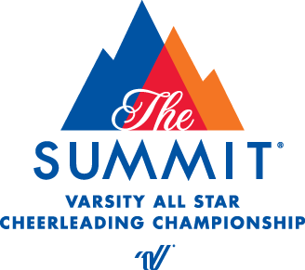
PRESS RELEASE
John Calitri
Varsity Spirit Special Events
jcalitri@varsity.com

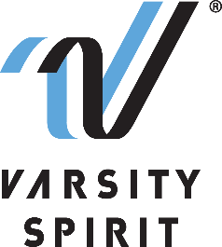

LOCAL [CHEERLEADER/DANCER] TO PERFORM AT THE VARSITY SPIRIT SPECTACULAR

[Your city, state, date] – [School Name] is proud to announce that a member of its [cheerleading/dance] team, [Name of athlete], will represent Varsity Spirit, the global leader in cheerleading, dance team and band apparel, camps and competitions, and a division of Varsity Brands, the market leader in team sports, school spirit and achievement recognition, in the 2022 Varsity Spirit Spectacular at The Walt Disney World® Resort on November 17-21, 2022.

Cheerleaders and dancers who are invited to perform in the Varsity Spirit Spectacular are part of a select group of high school Varsity Captains, Co-Captains and Officers identified at Varsity Spirit summer camps across the country hosted by Universal Cheerleaders Association (UCA), Universal Dance Association (UDA), National Cheerleaders Association (NCA), National Dance Alliance (NDA), United Spirit Association (USA) or Urban Cheerleading Experience (UCE). [School Name] attended [UCA/UDA/NCA/NDA/USA/UCE Camp] at [Camp Location] on [Camp Dates] where [He/She/They] was selected for this experience.

“We are thrilled that these excellent athletes will have the chance to perform and experience our Special Events in Orlando, FL,” said Bill Seely, President of Varsity Spirit. “We are honored to provide them a one-of-a-kind opportunity, where they will meet and connect with cheerleaders, dancers from across the country, and create memorable experiences at The Walt Disney World® Resort parks.”

[Name of athlete] will perform with fellow Varsity Captains, Co-Captains and Officers in a one-of-a-kind performance at The Walt Disney World® Resort. Besides enjoying a sunny trip to Orlando, athletes will have the opportunity to meet cheerleaders and dancers from across the nation and enjoy a magical holiday season at The Walt Disney World® Resort parks.

[Insert quote from athlete here, explaining what they are most looking forward to, or how they feel about being a part of this experience.]

Varsity Spirit is celebrating more than 30 years of honoring camp standouts. For more information, visit Varsity Spirit Spectacular.

About Varsity Spirit
Memphis-based Varsity Spirit, the driving force behind cheerleading’s dynamic transformation into the high-energy, athletic activity it is today, is the leading global source for all things spirit, including cheerleading, dance team and performing arts. A division of Varsity Brands, Varsity Spirit is a leader in uniform innovation, as well as educational camps, clinics and competitions, impacting more than a million athletes each year. Focused on safety, entertainment and leadership, Varsity Spirit’s employees have been dedicated to celebrating spirit through its brands since 1974. For more information about Varsity Spirit or Varsity Brands, please visit varsity.com or varsitybrands.com.

