FOR IMMEDIATE RELEASE:

Press Release: This is an example of a press release. Simply add your details to the bracketed sections (delete the brackets), and any additional information that makes this experience unique. Contact to your local news outlets (newspaper, radio stations) in your area with a good, clear photo of the athlete.
(Note – search your city, state “local news outlets” in google, and follow the steps to submit content. This may vary from news outlet to news outlet.)
Within the release below, there is a space for you to add your own quote. Please do not change any text that is not within brackets. Delete this paragraph before sending.

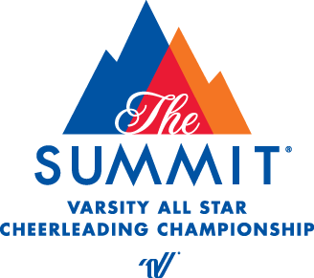
PRESS RELEASE
Contact: Melanie Berry
Varsity Spirit Special Events
mberry@varsity.com

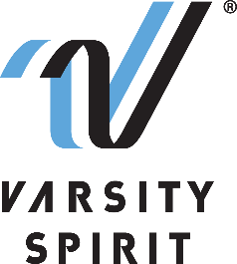

LOCAL HIGH SCHOOL [CHEERLEADER/DANCER/DRUM MAJOR] TO PERFORM IN THE LONDON NEW YEAR’S DAY PARADE

[Your city, state, date] – [School Name] is proud to announce that its [cheerleading/dance team/drum major] member, [Name of athlete], will represent Varsity Spirit, the global leader in cheerleading, dance team and band apparel, camps and competitions, and a division of Varsity Brands, the market leader in team sports, school spirit and achievement recognition, in the London New Year’s Day Parade in London, England from December 26, 2022 – January 3, 2023.

Cheerleaders, dancers, and drum majors who are invited to perform in the London New Year’s Day Parade are part of a select group of All-Americans identified at Varsity Spirit summer camps across the country. All-Americans are based on superior cheerleading, dance, or drum major skills as well as leadership skills at camps operated by Universal Cheerleaders Association (UCA), Universal Dance Association (UDA), National Cheerleaders Association (NCA), National Dance Alliance (NDA), United Spirit Association (USA) or Urban Cheerleading Experience (UCE). [School Name] attended [UCA/UDA/NCA/NDA/USA/UCE Camp] at [Camp Location] on [Camp Dates] where [He/She/They] was selected as an All-American. Only the top 12% of the cheerleaders and dancers from Varsity Spirit camps earn the chance to participate in a performance of this caliber.
“We are thrilled to be back participating in the London New Year’s Day Parade, and that these excellent athletes will have the chance to perform and experience our Special Events abroad,” said Bill Seely, President of Varsity Spirit. “We are honored to provide them a one-of-a-kind opportunity, where they will meet and connect with cheerleaders, dancers, and drum majors from across the United States, as well as be a part of an international and historical parade experience.”

[Name of Athlete] will perform with Varsity Spirit All-Americans in an exclusive performance on Piccadilly. Since its inaugural parade in 1987, the London New Year’s Day Parade attracts over 10,000 participants from the USA, UK, Europe and beyond to delight a street audience of over 500,000 and TV audience, which reaches more than 500,000,000 annually.

Besides being able to perform in a world-renowned parade, athletes will have the opportunity to meet cheerleaders and dancers from across the US and enjoy a memorable trip to one of the world’s most popular cities.

[Insert quote from participant here, explaining what they are most looking forward to, or how they feel about being a part of the London New Year’s Day Parade.]

The Varsity Spirit All-American program is celebrating more than 30 years of honoring camp standouts. For more information, visit London New Year's Day Parade.

About Varsity Spirit
Memphis-based Varsity Spirit, the driving force behind cheerleading’s dynamic transformation into the high-energy, athletic activity it is today, is the leading global source for all things spirit, including cheerleading, dance team and performing arts. A division of Varsity Brands, Varsity Spirit is a leader in uniform innovation, as well as educational camps, clinics and competitions, impacting more than a million athletes each year. Focused on safety, entertainment and leadership, Varsity Spirit’s employees have been dedicated to celebrating spirit through its brands since 1974. For more information about Varsity Spirit or Varsity Brands, please visit varsity.com or varsitybrands.com.

