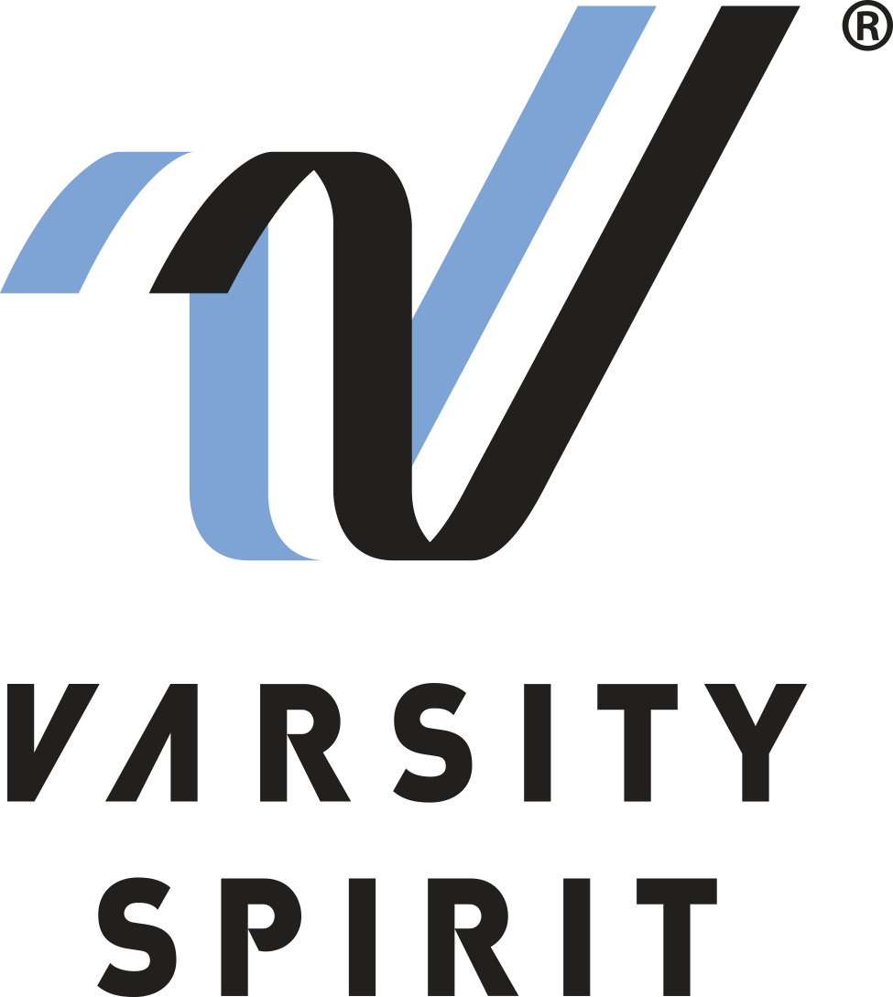
FOR IMMEDIATE RELEASE:

Contact:
Michelle Edwards
Varsity Special Events
medwards@varsity.com
(800) 238-0286

LOCAL CHEERLEADER/DANCER TO PERFORM IN THE PHILADELPHIA
THANKSGIVING DAY PARADE

Memphis, Tenn., (Date) – [Name _____________________] from [School Name ____________________] in [City, State __________________] has been selected along with more than 500 junior high and high school cheerleaders and dancers from across the U.S. to perform in the Annual Philadelphia Thanksgiving Day Parade, the oldest Thanksgiving Day parade in the nation.

The individuals invited to perform in the parade are cheerleading and dance All-Americans selected from Varsity Spirit camps around the country, including camps organized by Universal Cheerleaders Association (UCA), Universal Dance Association (UDA), National Cheerleaders Association (NCA), National Dance Alliance (NDA), and Urban Cheerleading Experience (UCE).

All-Americans will perform alongside massive floats and giant balloons, as well as favorites from the entertainment world as the 2021 Dunkin’ Donuts Thanksgiving Day Parade makes its way through the heart of historic Philadelphia, Pennsylvania. The event is televised in the Philadelphia area and syndicated throughout the United States.

[Name ______________________] earned the All-American title via tryout based on superior cheerleading or dance skills. Only the top 10% of the cheerleaders and dancers who attend Varsity Spirit camps in the summer receive this honor and the chance to march in this prestigious Thanksgiving Dau Parade. The All-American group will be in Philadelphia from November 23rd through the 26th, practicing their routine and visiting Philadelphia landmarks.

[Insert quote from All-American here, explaining what they are most looking forward to, or how they feel about being named an All-American.]

The Varsity Spirit All-American program is celebrating over 30 years. For more information, visit www.varsity.com or contact Michelle Edwards at (800) 238-0286, ext. 4532 or email medwards@varsity.com.

About Varsity Spirit
Memphis-based Varsity Spirit, the driving force behind cheerleading’s dynamic transformation into the high-energy, athletic activity it is today, is the leading global source for all things spirit, including cheerleading, dance team and performing arts. A division of Varsity Brands, Varsity Spirit is a leader in uniform innovation, as well as educational camps, clinics and competitions, impacting more than a million athletes each year. Focused on safety, entertainment and traditional school leadership, Varsity Spirit’s employees have been dedicated to celebrating spirit through its brands since 1974. For more information about Varsity Spirit or Varsity Brands, please visit varsity.com or varsitybrands.com.

