Press Release: This is an example of a press release. Simply add in the details of your program to the bracketed sections (delete the brackets), and email or mail to various news outlets (newspaper, radio stations) in your area with a good, clear picture of your team. There is a space for you to add your own quote. Please do not change any text that is not within brackets. Delete this paragraph before sending.

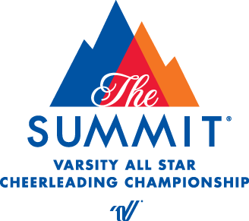
PRESS RELEASE
[Your contact name]
[Telephone number]
[E-mail address]

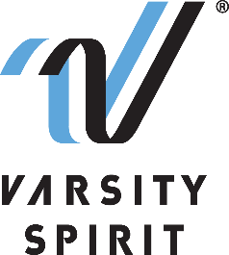

Local cheerleading program QUALIFIES TO ATTEND USA SPIRIT NATIONALS IN ANAHEIM, CA

[Your city, state, date] – [School Name], a local spirit team, is proud to announce that their team(s) [has/have] qualified to compete at one of the nation’s most prestigious cheerleading competitions, USA Spirit Nationals, produced by the United Spirit Association. The United Spirit Association is a division of Varsity Spirit – the global leader in cheerleading, dance team and band apparel, camps and competitions, and a division of Varsity Brands, the market leader in team sports, school spirit and achievement recognition.

The USA Spirit Nationals, held at the Anaheim Convention Center, in Anaheim, CA on February 24-26, 2023, is the season-capping goal for many competitive high school teams. In 2023, the event will showcase more than 7,000 athletes. USA Spirit Nationals began in 1986, bringing together competitors from the cheerleading, song/pom, mascot and pep flag activities.

In order to qualify and receive a bid to compete at USA Spirit Nationals, [the School’s name/team’s name] athletes had to earn a bid at a qualifying event held during the official competition season and obtain a NFHS Squad Credentialing certificate at a Varsity Spirit Summer Training Camp. The [School name/Team name] will be competing on February 24-26, 2023. Fans at home can watch a livestream of the event on Varsity TV on varsity.com

“SCHOOL ADMIN OR COACH’S QUOTE HERE,” says [John/Jane Doe, Admin Title/Coach of School Name/Team name].

For more information on USA Spirit Nationals, please visit here.

About Varsity Spirit
Memphis-based Varsity Spirit, the driving force behind cheerleading’s dynamic transformation into the high-energy, athletic activity it is today, is the leading global source for all things spirit, including cheerleading, dance team and performing arts. A division of Varsity Brands, Varsity Spirit is a leader in uniform innovation, as well as educational camps, clinics and competitions, impacting more than a million athletes each year. Focused on safety, entertainment and leadership, Varsity Spirit’s employees have been dedicated to celebrating spirit through its brands since 1974. For more information about Varsity Spirit or Varsity Brands, please visit varsity.com or varsitybrands.com.

###

