Press Release: This is an example of a press release. Simply add in the details of your program to the bracketed sections (delete the brackets), and any additional information that makes this championship unique for your program. Contact to your local news outlets (newspaper, radio stations) in your area with a good, clear picture of your team.
(Note – search your city, state “local news outlets” in google, and follow the steps to submit content. This may vary from news outlet to news outlet.)
Within the release below, there is a space for you to add your own quote from a school/community leader. Please do not change any text that is not within brackets. Delete this paragraph before sending.

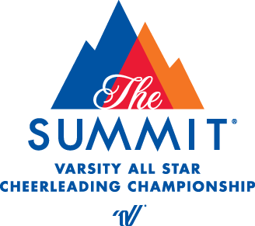
PRESS RELEASE
[Your contact name]
[Telephone number]
[E-mail address]

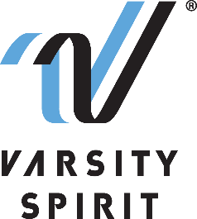

LOCAL HIGH SCHOOL TEAM FINISHES IN [ ____ ] PLACE AT THE UDA NATIONAL DANCE TEAM CHAMPIONSHIP AT THE WALT DISNEY WORLD® RESORT IN FLORIDA

[Your city, state, date] – [School Name] is proud to announce that their dance team(s) competed at one of the nation’s most prestigious dance competitions, the National Dance Team Championship, and finished in [ ____ ] place. The National Dance Team Championship is produced by the Universal Dance Association (UDA), a division of Varsity Spirit – the global leader in cheerleading, dance team and band apparel, camps and competitions, and a division of Varsity Brands, the market leader in team sports, school spirit and achievement recognition.

The National Dance Team Championship, held at the ESPN Wide World of Sports Complex at The Walt Disney World® Resort on February 4-6, 2022, is the pinnacle of dance team competitions for high school and all star dancers across the country. All teams invited to perform at the championship qualified at a Varsity Spirit Camp 2021. School teams were credentialed in dance safety and leadership training, endorsed by the National Federation of High School Sports (NFHS), as well as in the areas of ambassadorship, athleticism, performance, role modeling and spirit raising. Teams performed in an exclusive performance at ESPN Wide World of Sports Complex in the HP Field House, Visa Athletic Center or The AdventHealth Arena – the first ever building dedicated to exclusively hosting cheer and dance events.

“Each year, teams from across the country come together at the UDA National Dance Team Championship to showcase their skills and represent their schools and programs,” said Bill Seely, President of Varsity Spirit. “These athletes have spent hundreds of hours raising spirit on their campuses, entertaining their crowds at games and performances. We are thrilled to be able to produce a world-class event where we can highlight their incredible talents and reward them for their contributions to their schools and communities.”

The National Dance Team Championship was the first of its kind in 1983, created to reward dancers for their hard work and talent, and to create a venue in which they could be recognized for their talents and abilities. This championship has been featured on ESPN since 1983 and Varsity Spirit is one of ESPN’s longest-running collaborators. Varsity Spirit partnered with the Walt Disney World® Resort in 1995 and has been creating unforgettable National Championship experiences ever since.
[“ATHLETIC DIRECTOR OR COACH’S QUOTE HERE,”] says [John/Jane Doe, AD/Coach of School/Team name].

For more information on the National Dance Team Championship, please visit Varsity.com. Varsity Spirit live streamed the championship on Varsity TV, a website dedicated to exclusive live coverage and video libraries of Varsity Spirit cheer and dance competitions. Videos of the routines are available for fans who were otherwise unable to attend, and full results listings are available on Varsity TV. The championship will air on ESPN2 and ESPNU beginning in the Spring of 2022. Viewers can check their local listings for air times.

About Varsity Spirit
Memphis-based Varsity Spirit, the driving force behind cheerleading’s dynamic transformation into the high-energy, athletic activity it is today, is the leading global source for all things spirit, including cheerleading, dance team and performing arts. A division of Varsity Brands, Varsity Spirit is a leader in uniform innovation, as well as educational camps, clinics and competitions, impacting more than a million athletes each year. Focused on safety, entertainment and leadership, Varsity Spirit’s employees have been dedicated to celebrating spirit through its brands since 1974. For more information about Varsity Spirit or Varsity Brands, please visit varsity.com or varsitybrands.com.

###

