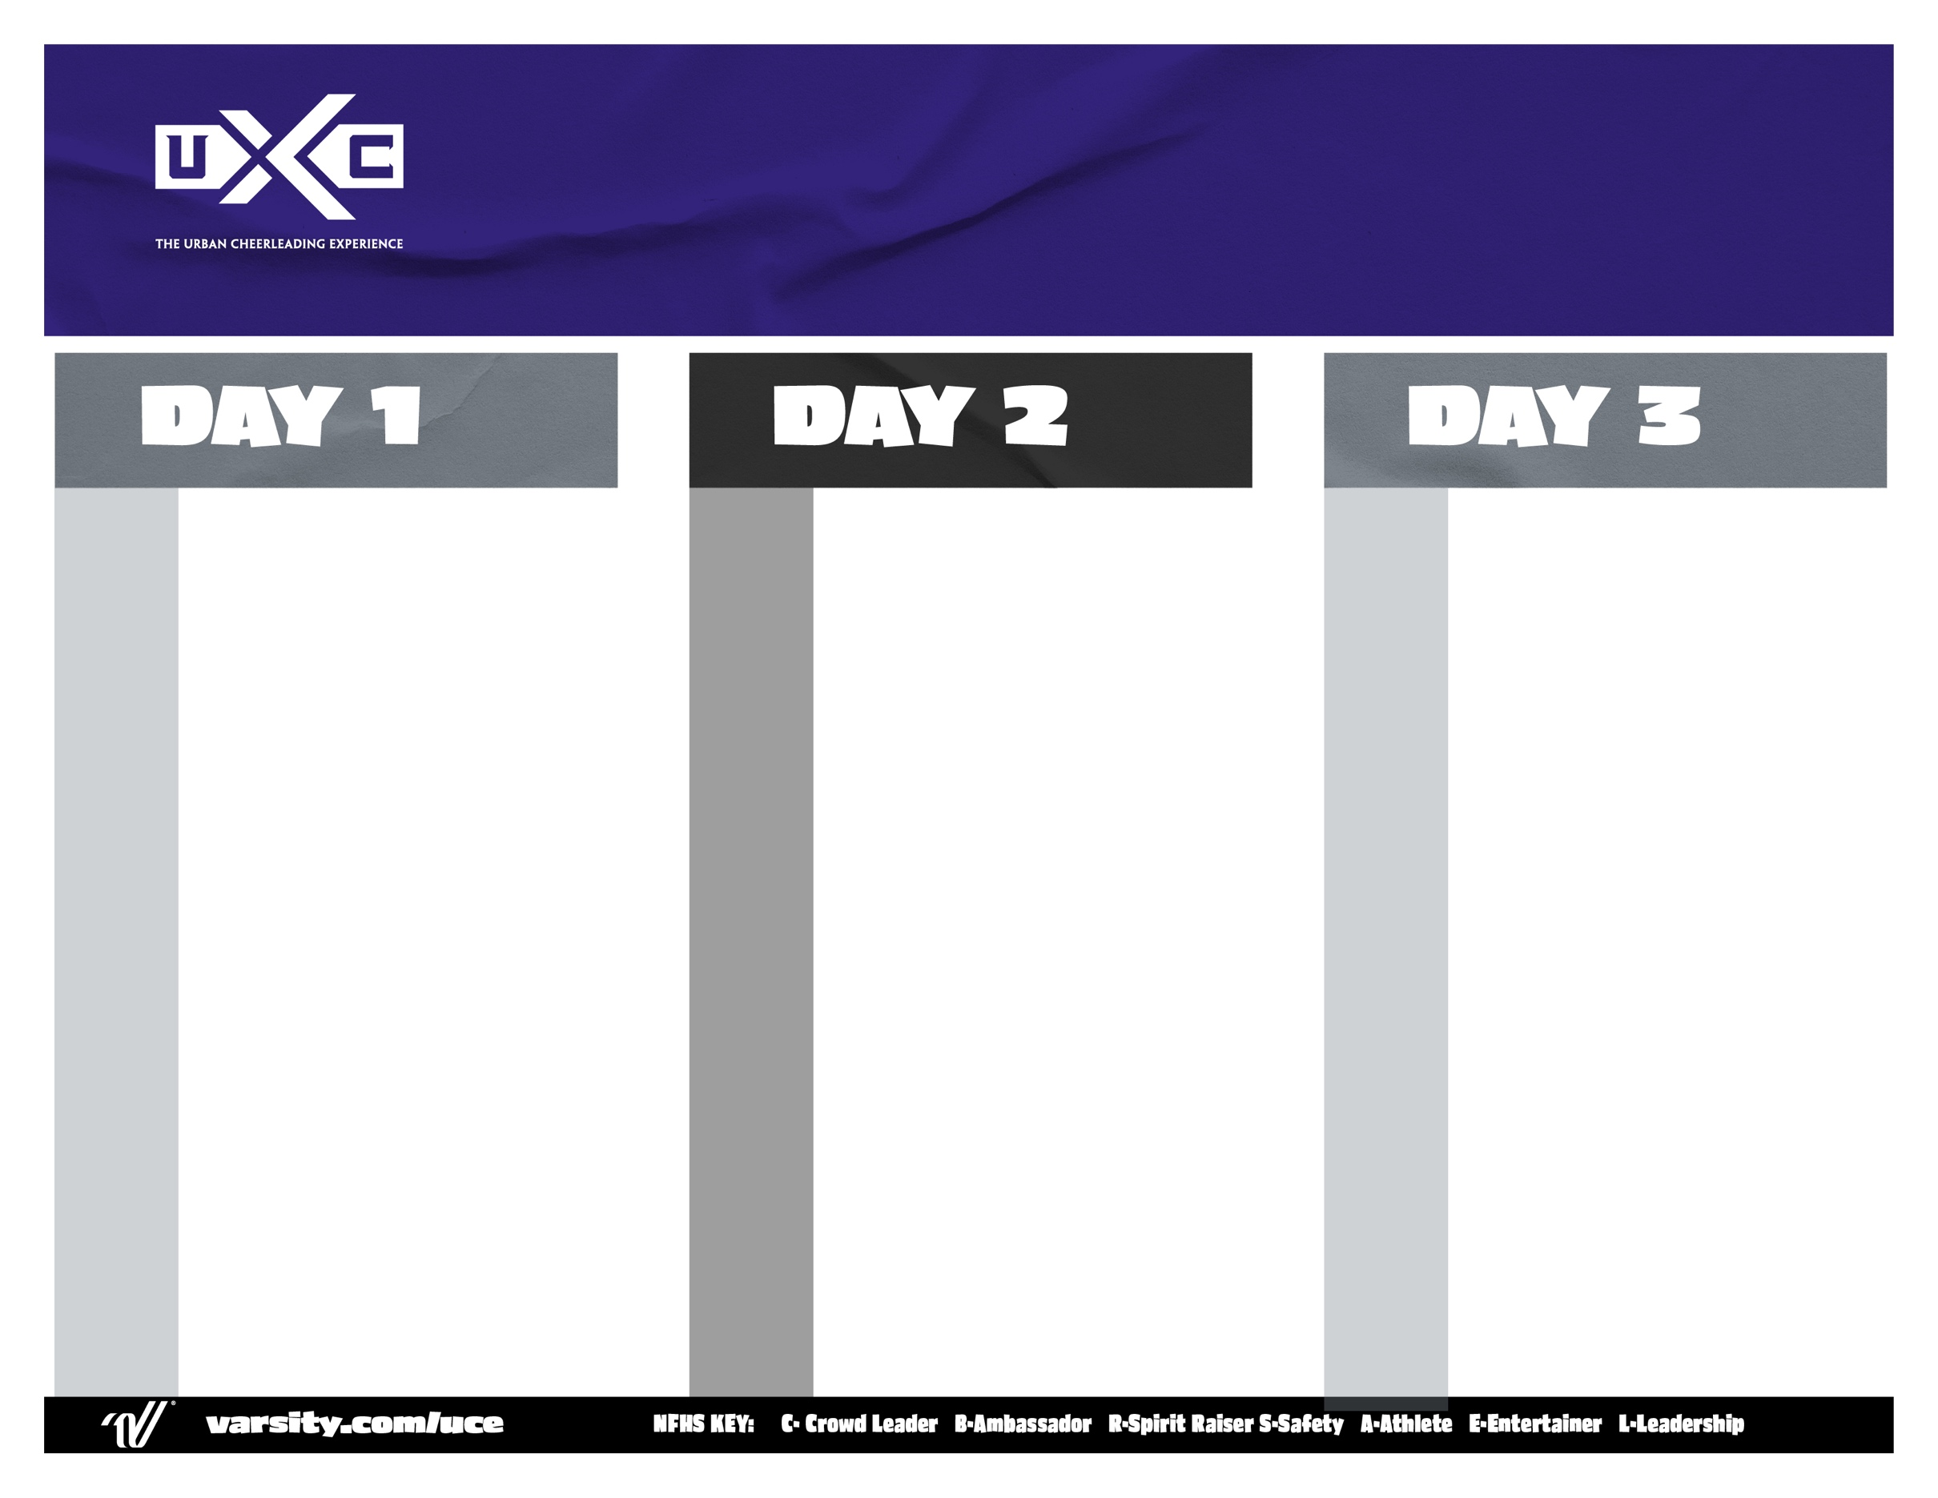

Breakfast

Game Day Traditions

Pyramid Class

**“U” the Future:** Leadership Training (L)

“U-Tine” PCH

Hip-Hop Dance Class

**LUNCH**

Purple Group Lunch

Silver Group Lunch

Open Practice

U-Tine Evaluations

Mentor Meeting: Beyond U (E)

Rally of The Future

Open Practice

Cheer Live Showcase//Final Awards

6 – 8:00am

8:00am

8:45am

9:30am

10:00am

11:00am

11:30am

11:45am

1:30pm

1:45pm

2:15pm

2:45pm

3:15pm

4:00pm

Breakfast

“U” Jump Class

**“The Fan Experience” -** Cheers & Chants

Band Dance Dynamics

Stunt Class

Cheer PCH Prep

**LUNCH – Senior Working Lunch**

Silver Group Lunch

Purple Group Lunch

**Purple:** Cheer PCH

**Silver:** Cheer Live – Performance Cheers

SWITCH

ROTATIONS

All-American Prep//Shake It Up 101

All-American Tryouts

**DINNER**

Purple Group Dinner

Silver Group Dinner

Open Practice

Cheer Evaluations

“U” Jump Championships

Daily Awards//Beyond U (R&A)

6 - 8:00am

8:00am

8:45am

9:30am

10:15am

11:15am

11:30am

11:45am

1:30pm

2:15pm

3:00pm

3:30pm

4:30pm

4:45pm

6:15pm

6:30pm

7:00pm

7:45pm

Overnight Camp

WITH EXTENDED DAY 3

9:00am

12:00pm

1:00pm

1:30pm

2:15pm

3:15pm

4:15pm

4:30pm

4:45pm

6:30pm

7:00pm

7:15pm

7:30pm

7:45pm

Registration Opens

Registration Closes

“Cheer Live” Opening Rally

**“The Fan Experience”**

Cheers & Chants

“U-Tine” Dance Class

Stunt Class

Mentor Meeting

**Dinner Break**

Purple Group

Silver Group

**Hello Cheer**

Home Cheer Evals

Sideline PCH

Sideline Evals

Mentor Meeting – Beyond U (C&B)

Material Review

Daily Awards