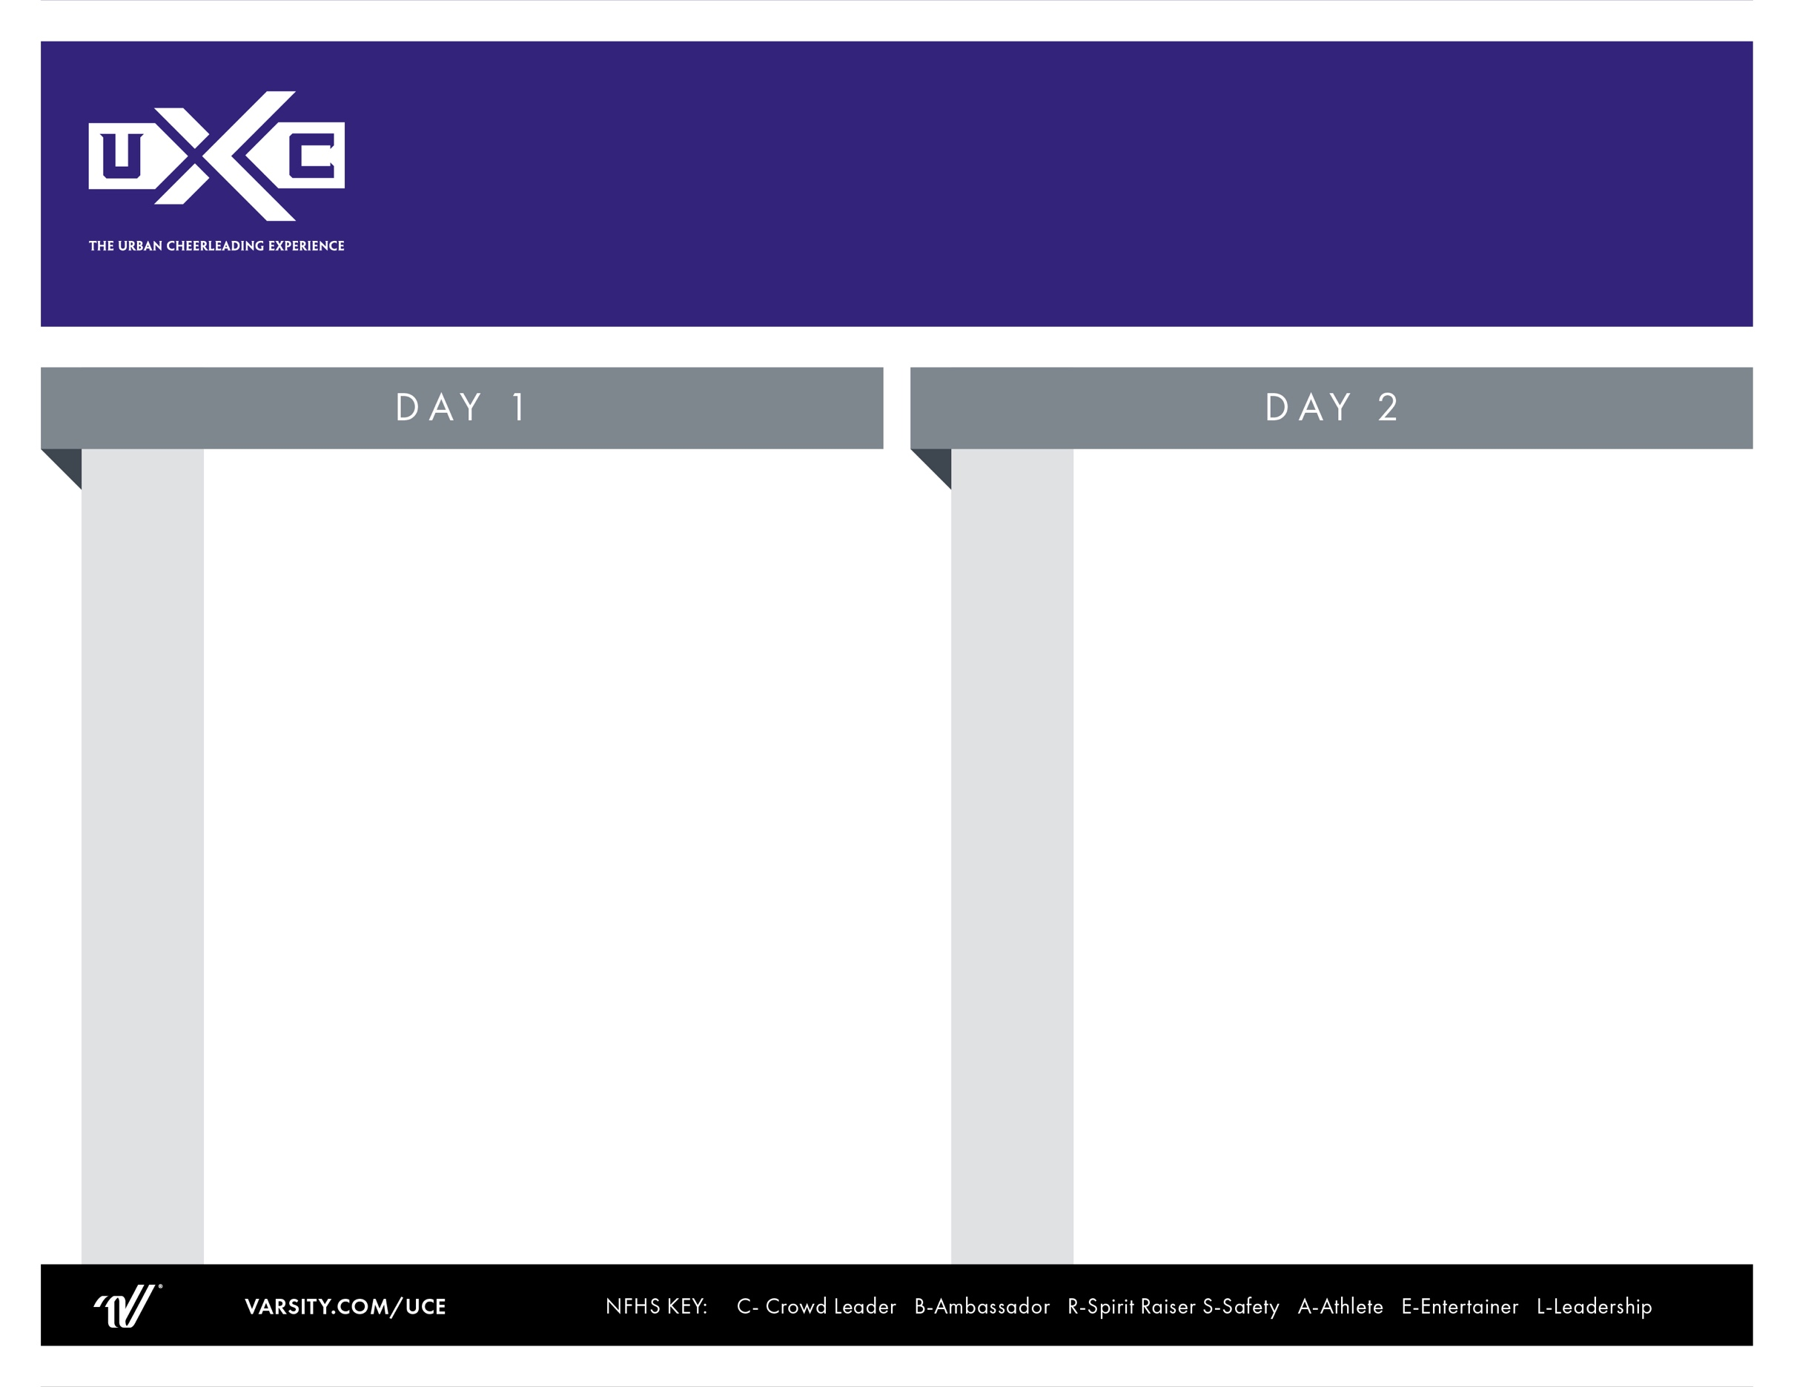

Warm-Up

**Game Day Live**

Cheers & Chants

Band Dance Dynamics

Pyramid Class

TUCE All-American Tryouts

Lunch

*Open Practice*

Cheer Evals

“U”Tine PCH

Performance Cheers & Counts

Beyond U: Squad Credentialing

“U”Tine Evals

**Game Day Live**

*Game Day Routine Review*

Parent Showcase

9:00 AM

9:15 AM

10:00 AM

10:45 AM

11:15 AM

12:00 PM

1:00 PM

1:15 PM

1:30 PM

2:15 PM

3:00 PM

3:15PM

3:30 PM

4:00 PM

Registration Opens

Staff Introductions/Game Day Live Opening Demo

**Game Day Live**

Cheers & Chants

“U”Tine Dance Class

Safety Awareness & Stunt Qualification

w/Mentor

Stunt Class #1

Lunch

Open Practice

**HOMECOMING:**

*Hello Cheer Show Us Your Traditions!*

Cheer PCH

Beyond U: Squad Credentialing/St Jude

Jump “U” – Class

Sideline PCH

Material Review

Daily Awards

8:30 AM

9:00 AM

9:15 AM

10:00 AM

10:45 AM

11:00 AM

12:00 PM

1:00 PM

1:15 PM

1:30 PM

2:15 PM

2:45 PM

3:15 PM

3:30 PM

4:00 PM

**2 Day Cheer Camp**