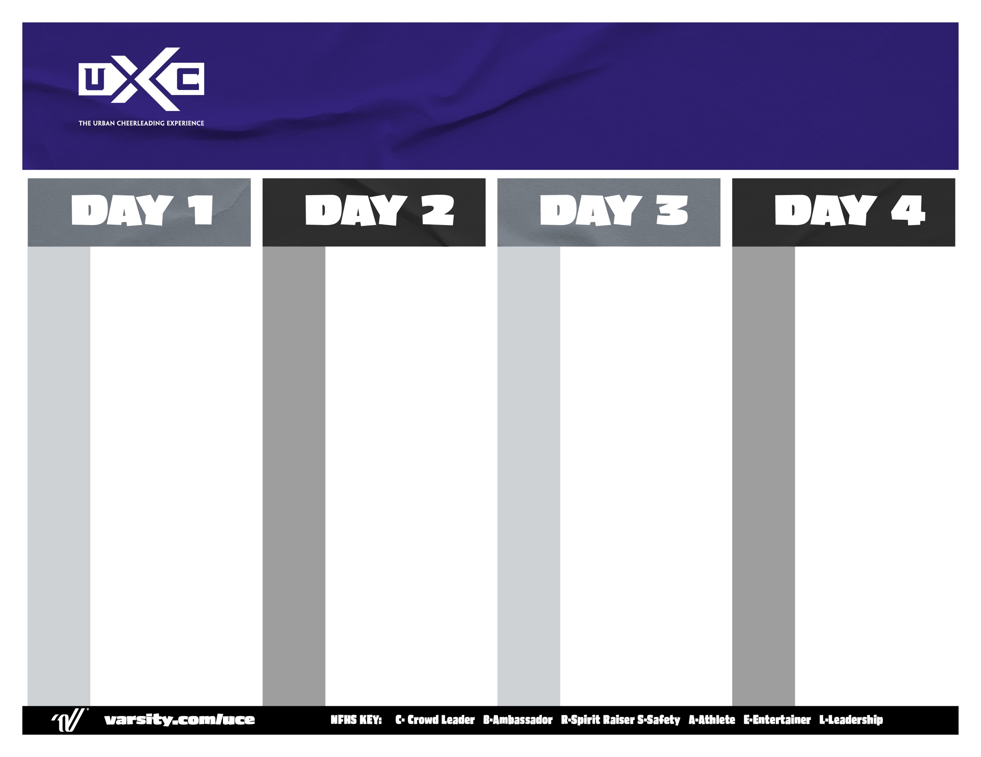

7:00 AM Breakfast

9:00 AM Mentor Meeting | Beyond U

9:30 AM Open Practice

10:00 AM Game Day & Routine Performances

11:00 AM Final Awards

7:00 AM Breakfast

8:15 AM Warm - Up

9:00 AM **Game Day Live:**

Game Day Traditions

9:30 AM “**Level Up 3”**

Floor Progressions Tech.

ADVANCED LEAPS & TURNS

10:00 AM Style Routine Level 2  
 Hip-Hop | Jazz | Pom

10:45 AM **Purple:** Style Routine – PCH

**Silver:** Beyond U – Pep Rally

Prep

11:30 AM Lunch *\*\* Senior Working Lunch  
 Leadership Training*  
1:30 PM **Purple:** Rotate

**Silver:** Rotate

2:15 PM Open Practice

2:30 PM Style Routine Evals

3:00 PM T.U.C.E All-American Tryouts

4:00 PM “Wind Down” – Body Cool Down

4:15 PM Mentor Meeting | Material Review

4:30 PM Dinner

6:30 PM Style Routine Level 3  
 Hip-Hop | Jazz | Pom | Kick

7:30 PM The Throwback Rally

Daily Awards

8:00 PM Beyond U | Daily Awards

Lecel

7:00 AM

8:00 AM

8:15 AM

9:00 AM

9:30 AM

10:15 AM

11:15 AM

11:30 AM

1:30 PM

2:15 PM

3:00 PM

3:30 PM Style Routine PCH

4:15 PM **Mentor Meeting**

4:30 PM Dinner

6:30 PM Open Practice

6:45 PM U-Tine Evaluations

7:15 PM Dancer Elite Competition

8:00 PM Beyond U | Daily Awards

Breakfast

Leadership Class   
*\*Team Leaders Only\**

Warm-Up

“**Level Up 2”**

Floor Progressions Tech. – TURNS

Band Dance Dynamics

Style Routine – Level 1  
Hip-Hop | Jazz | Pom  
Lunch

**Mentor Meeting**

**Purple:** U-Tine PCH

**Silver:** Improv Session

*ROTATE*

**Elective Classes**Kick Routine | Specialty Classes

Registration Opens

Registration Closes

“Dance Live” Opening Demo

“**Level Up 1”**

Floor Progressions Tech.

KICKS & TURN PREPS

**“The Fan Experience”**

Field Show Routine

***\*\*\*Coaches Meeting***

**S / R / M**

Stand Routines/ Ripples/ Marches

**Mentor Meeting w/ Coaches**

Dinner

**Home Routine Evals**

*\*Show us what you got!*

“U” Tine Camp Dance

5th Quarter – S/R/M PCH

5th Quarter – S/R/M Evals

**Mentor Meeting**

Beyond U – St. Jude Awards

Daily Awards

9:00 AM

12:00 PM

1:00 PM

1:30 PM

2:45 PM

3:30 PM

4:15 PM

4:30 PM

6:30 PM

7:00 PM

7:45 PM

8:00 PM

8:15 PM

8:30 PM

Traditional Overnight Dance Camp