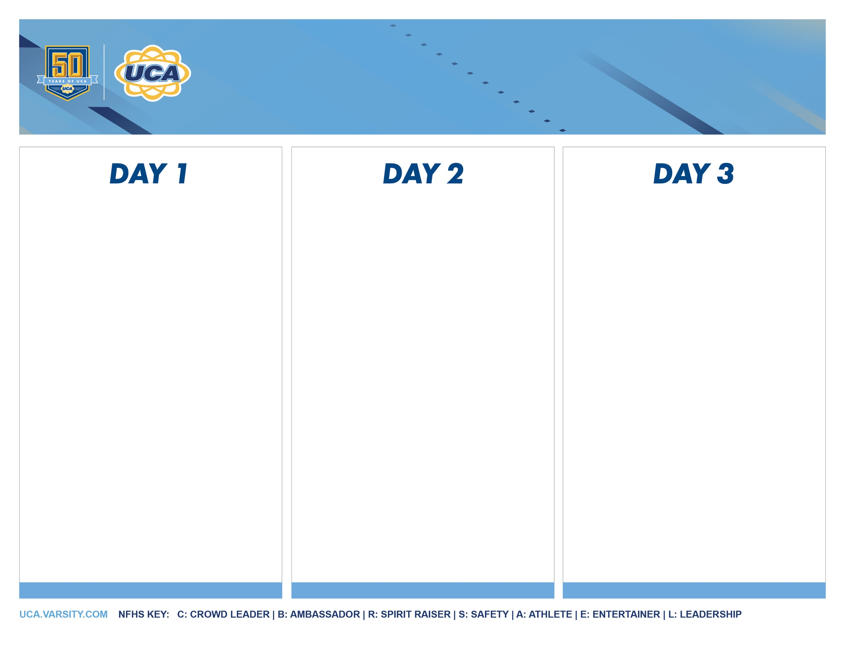

**2024 Christian Camp**

***3-Day Sample Schedule***

*Breakfast*

Optional Open Practice

Team Time w/ Team Leader

Camp Routine Championship

Situational Sideline & Crowd Leading Championship

Squad Credentialing Presentation

Senior Recognition Ceremony

Final Awards & Pin It Forward

Final Christian Leadership & Closing Prayer

8:30 am

9:00 am

9:30 am

10:15 am

11:00 am

11:15 am

11:30 am

11:40 am

*Breakfast*

Team Leader Check-In / Warmup / Material Review / Stretching, Flexibility & Jump Class

& *Coaches’ Meeting #3*

Coaches’ & Captain’s Goal Setting

Stunt Class #2

**Group A** – Team UCA & FNL Frenzy w/ Game Day Jams - ***NEW!***!

**Group B** – Crowd Leading Private Coaching

**Switch Groups**

*Lunch*

Coaches’ Stunt Workshop & Captain’s

Leadership Training

Situational Sideline & Crowd Leading Evaluations

Pyramid Private Coaching

**Group A** ‒ Team Unity & Sideline Stunts

**Group B** ‒ Camp Routine Private Coaching

**Switch Groups**

Jump Off

*Dinner*

Camp Routine Evaluations

All-American Tryouts

St. Jude & Team Time w/ Team Leader

Gatorade Break  
*Spirit Night!*

Squad Credentialing / Daily Awards / Pin It Forward / Devotional & Worship

*Final Coaches’ Q&A*

8:30 am

9:00 am

9:15 am

10:00 am

10:45 am

11:30 am

1:00 pm

1:15 pm

1:45 pm

2:45 pm

3:30 pm

4:15 pm

4:30 pm

6:00 pm

6:30 pm

7:00 pm

7:45 pm

8:00 pm

8:30 pm

9 am ‐ 12 pm

12:30 pm

1:00 pm

1:30 pm

1:45 pm

2:00 pm

3:00 pm

4:00 pm

4:30 pm

6:00 pm

6:15 pm

6:45 pm

7:30 pm

8:15 pm

8:45 pm

*Registration*

Coaches’ Quick Meet! **– *NEW!***

Opening Prayer / Staff Demo & Meet your Team Leader!

Safety Awareness & Stunt Qualification w/ Team Leader

Spotting Seminar

Motion & Spirit Prop Workshop / Game Day Class: Situational Sidelines / Camp Dance & *Coaches’ Meeting #1*

Stunt Class #1

**Group A** – Situational Sideline Private

Coaching

**Group B** – Motion Technique Class &

Team UCA

*Dinner*

Senior Social **– *NEW!***

**Switch Groups**

Pyramid Class #1

Game Day Class: Crowd Leading

Stunt Troubleshooting Class

Team Leader Meetings / Daily Awards / Devotional & Worship

*New Coaches’ Q/A*