Press Release: This is an example of a press release. Simply add in the details of your program to the bracketed sections (delete the brackets), and email or mail to various news outlets (newspaper, radio stations) in your area with a good, clear picture of your team. There is a space for you to add your own quote. Please do not change any text that is not within brackets. Delete this paragraph before sending.

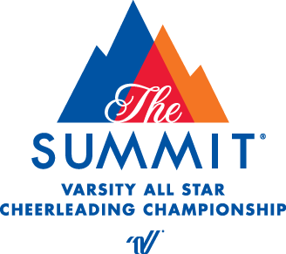
PRESS RELEASE
[Your contact name]
[Telephone number]
[E-mail address]

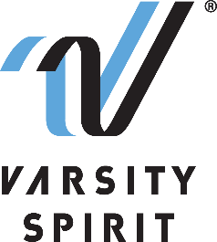

LOCAL HIGH SCHOOL TEAM QUALIFIES TO COMPETE IN THE UCA NATIONAL HIGH SCHOOL CHEERLEADING CHAMPIONSHIP AT THE WALT DISNEY WORLD® RESORT IN FLORIDA

[Your city, state, date] – [School Name] is proud to announce that their cheerleading team(s) [has/have] been selected to compete at one of the nation’s most prestigious cheerleading competitions, the National High School Cheerleading Championship, produced by Universal Cheerleaders Association (UCA). UCA is a division of Varsity Spirit – the global leader in cheerleading, dance team and band apparel, camps and competitions, and a division of Varsity Brands, the market leader in team sports, school spirit and achievement recognition.

The National High School Cheerleading Championship, held at the ESPN Wide World of Sports Complex at The Walt Disney World® Resort on February 11-13, 2022, is the pinnacle of cheerleading competitions for high school cheerleaders across the country. All teams invited to compete at the championship qualified at a regional competition in 2021. Teams were credentialed in cheer safety and leadership training, endorsed by the National Federation of High School Sports (NFHS), as well as in the areas of crowd leading, spirit raising, ambassadorship, athleticism, and entertainment. Squad members will travel as a team to Orlando, FL to compete in the division that they received a bid at their regional competition. Teams will perform in an exclusive performance at ESPN Wide World of Sports Complex in the HP Field House, Visa Athletic Center or The AdventHealth Arena – the first ever building dedicated to exclusively hosting cheer and dance events.

“We are excited to again host safe, in person events where teams from across the country can earn the opportunity to compete at the National High School Cheerleading Championship” said Bill Seely, President of Varsity Spirit. “These incredible athletes spend over 90% of their time focused on building engagement in their schools, and they’ve learned to navigate that in new and innovative ways in the last eighteen months. We are thrilled to be able to produce a world-class event where we can recognize and reward these incredible young people for their contribution to their schools and communities, dedication and talent.”

The National High School Cheerleading Championship was the first of its kind in 1980, created to reward cheerleaders for their work on the sidelines and to create a venue in which they could be recognized for their talents and abilities. This championship has been featured on ESPN since 1983 and Varsity Spirit is one of ESPN’s longest-running collaborators. Varsity Spirit partnered with the Walt Disney World® Resort in 1995 and has been creating unforgettable National Championship experiences ever since.
“ATHLETIC DIRECTOR OR COACH’S QUOTE HERE,” says [John/Jane Doe, AD/Coach of School/Team name].

For more information on the National High School Cheerleading Championship, please visit Varsity.com. Varsity Spirit will live stream the championship on Varsity TV, a website dedicated to exclusive live coverage and video libraries of Varsity Spirit cheer and dance competitions. Videos of the routines are available for fans who were otherwise unable to attend, and full results listings will be available. The championship will air on ESPN2 and ESPNU beginning in the Spring of 2022. Viewers can check their local listings for air times.

About Varsity Spirit
Memphis-based Varsity Spirit, the driving force behind cheerleading’s dynamic transformation into the high-energy, athletic activity it is today, is the leading global source for all things spirit, including cheerleading, dance team and performing arts. A division of Varsity Brands, Varsity Spirit is a leader in uniform innovation, as well as educational camps, clinics and competitions, impacting more than a million athletes each year. Focused on safety, entertainment and leadership, Varsity Spirit’s employees have been dedicated to celebrating spirit through its brands since 1974. For more information about Varsity Spirit or Varsity Brands, please visit varsity.com or varsitybrands.com.

###

