Press Release: This is an example of a press release. Simply add in the details of your program to the bracketed sections (delete the brackets), and email or mail to various news outlets (newspaper, radio stations) in your area with a good, clear picture of your team. There is a space for you to add your own quote. Please do not change any text that is not within brackets. Delete this paragraph before sending.

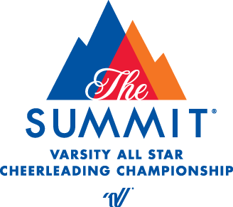
PRESS RELEASE
[Your contact name]
[Telephone number]
[E-mail address]

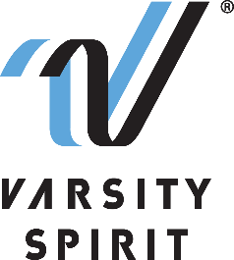

LOCAL HIGH SCHOOL TEAM QUALIFIES TO COMPETE IN THE NDA NATIONAL CHAMPIONSHIP IN ORLANDO, FL

[Your city, state, date] – [School Name] is proud to announce that their dance team(s) [has/have] been selected to compete at one of the nation’s most prestigious dance competitions, the NDA National Championship, produced by the National Dance Alliance (NDA). NDA is a division of Varsity Spirit – the global leader in cheerleading, dance team and band apparel, camps and competitions, and a division of Varsity Brands, the market leader in team sports, school spirit and achievement recognition.

The NDA National Championship will be held at the Caribe Royale Orlando on March 4-6, 2022. All teams invited to perform at the championship received eligibility by attending a Varsity Spirit Camp, competing at a NDA Regional or Classic Championship, or submitting a video qualification. Teams were credentialed in dance safety and leadership training, endorsed by the National Federation of High School Sports (NFHS), as well as in the areas of ambassadorship, athleticism, performance, role modeling and spirit raising.

“We are excited to again host safe, in person events where teams from across the country can earn the opportunity to compete at NDA National Championship” said Bill Seely, President of Varsity Spirit. “These incredible athletes spend over 90% of their time focused on building engagement in their schools, and they’ve learned to navigate that in new and innovative ways in the last eighteen months. We are thrilled to be able to produce a world-class event where we can recognize and reward these incredible young people for their contribution to their schools and communities, dedication and talent.”

Squad members will travel as a team to Orlando, FL to compete in the [DIVISION NAME] division where they will demonstrate school pride and athleticism on the competition floor. In addition to competing for a national championship, teams will enjoy exploring all that Orlando, FL has to offer and have the opportunity to meet other cheerleaders from across the nation.
“ATHLETIC DIRECTOR OR COACH’S QUOTE HERE,” says [John/Jane Doe, AD/Coach of School/Team name].

For more information on the NDA National Championship, please visit Varsity.com. Varsity Spirit will live stream the championship on Varsity TV, a website dedicated to exclusive live coverage and video libraries of Varsity Spirit cheer and dance competitions. Videos of the routines are available for fans who were otherwise unable to attend, and full results listings will be available.

About Varsity Spirit
Memphis-based Varsity Spirit, the driving force behind cheerleading’s dynamic transformation into the high-energy, athletic activity it is today, is the leading global source for all things spirit, including cheerleading, dance team and performing arts. A division of Varsity Brands, Varsity Spirit is a leader in uniform innovation, as well as educational camps, clinics and competitions, impacting more than a million athletes each year. Focused on safety, entertainment and leadership, Varsity Spirit’s employees have been dedicated to celebrating spirit through its brands since 1974. For more information about Varsity Spirit or Varsity Brands, please visit varsity.com or varsitybrands.com.

###

