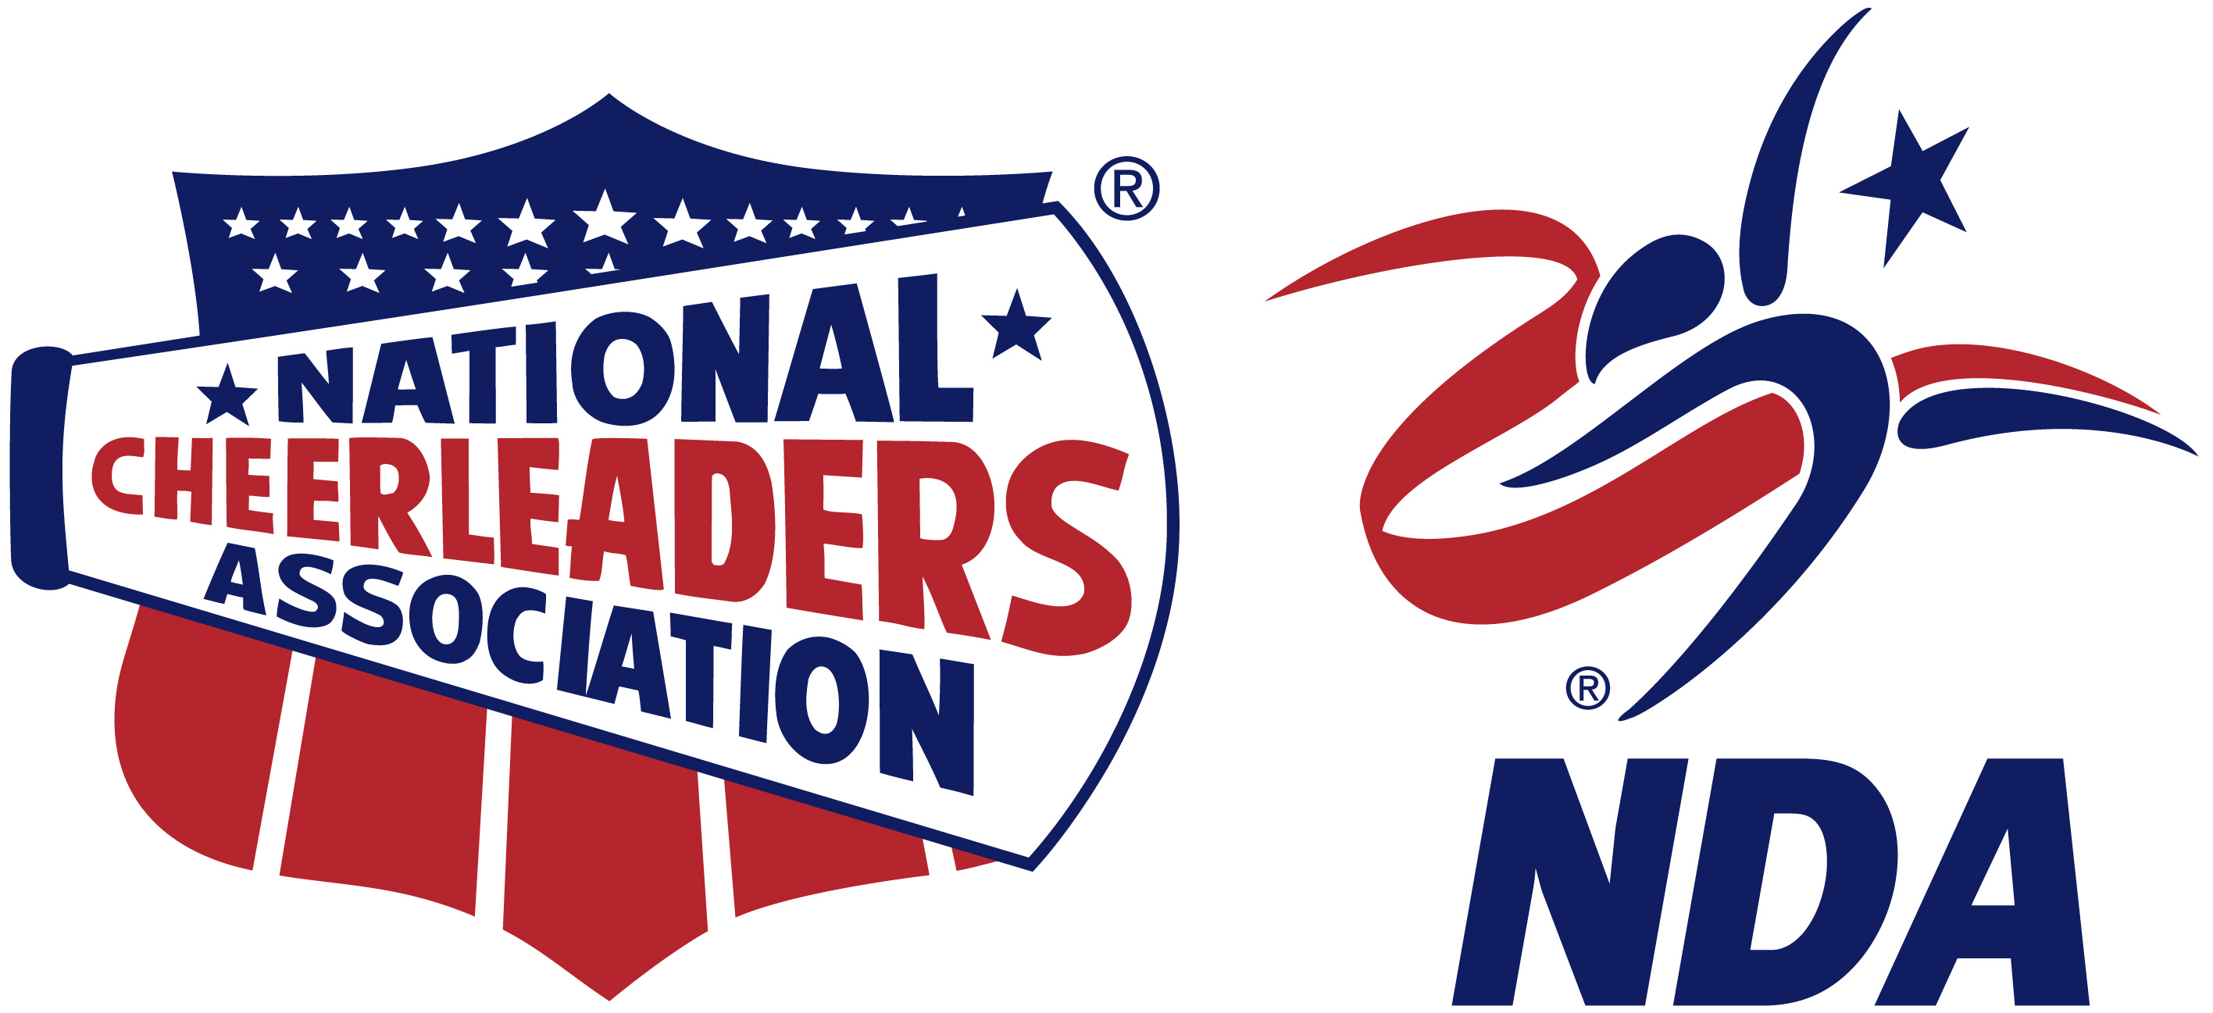
FOR IMMEDIATE RELEASE:

Contact:
Bill Boggs
Director of College Programs
(803) 865-6501
bboggs@varsity.com

LOCAL CHEER AND DANCE TEAM COMPETED AT THE NCA & NDA COLLEGIATE CHEER AND DANCE NATIONAL CHAMPIONSHIP IN DAYTONA BEACH, FLORIDA

Daytona Beach, FL – The [Team Name ________________________] cheerleading team from [City, State _____________________] joined cheerleaders and dancers from across the country to compete at the NCA & NDA Collegiate Cheer and Dance National Championship on April 7-11, 2021 in Daytona Beach, Florida.

Teams gathered in Daytona Beach to compete Oceanside in hopes of winning the title of NCA & NDA Collegiate National Champion and taking home the coveted golden trophy. [Team Name ________________] competed in the [Division________________] where they placed [Team Placement______] out of [Number of Teams in Division____] teams.

[Team Name ___________________] had the once in a lifetime experience of performing outdoors on the Bandshell in front of hundreds of fans. Besides competing for a national championship, teams got to enjoy sunny Daytona Beach, Florida and had the opportunity to meet other cheerleaders and dancers from universities across the nation.

[Insert quote from athlete here, explaining what their favorite memory was, or how they felt about competing at NCA & NDA College Nationals.]

For more information, visit nca.varsity.com and nda.varsity.com or contact Bill Boggs at (803) 865-6501 or bboggs@varsity.com.

About the National Cheerleaders Association
Founded in 1948 by Lawrence “Herkie” Herkimer, NCA was the first cheerleading company. Today, NCA trains cheerleading teams across the country at hundreds of summer camps, and hosts competitions for teams to demonstrate their athleticism. For more information about the National Cheerleaders Association, visit nca.varsity.com.

About the National Dance Alliance
NDA was created in 1976 and has led the way in dance team training since that time. Today NDA trains dance teams across the country at hundreds of summer camps, and hosts competitions for teams to demonstrate their skill and athleticism. For more information about the National Dance Alliance, visit nda.varsity.com.

