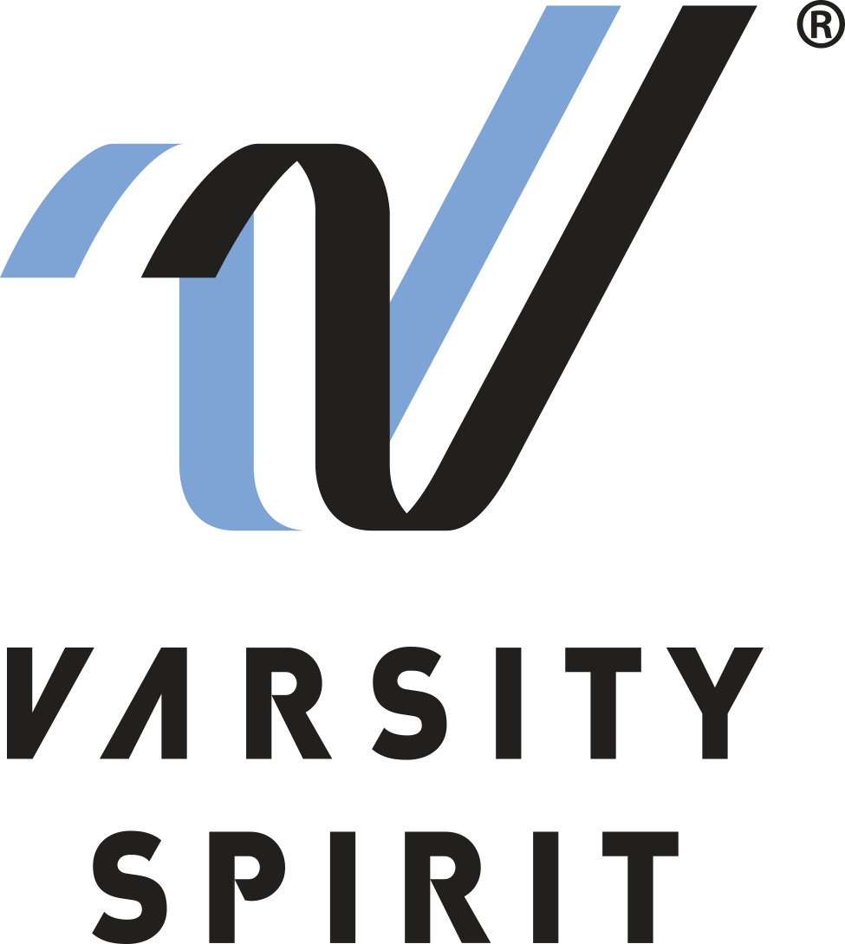
FOR IMMEDIATE RELEASE:

Contact:
Mike Fultz
Varsity London Tour
(800) 238-0286, ext. 4329
mfultz@varsity.com

LOCAL CHEERLEADER/DANCER TO PERFORM IN THE LONDON NEW YEAR’S DAY PARADE FOR THE 30th YEAR

Memphis, Tenn., (Date) [Name_____________________] from
[High School___________________] in [City, State _______________________] is one of more than 650 high school cheerleaders and dancers from across the U.S. who will be representing Varsity Spirit in the world famous London New Year’s Day Parade.

The individuals invited to perform in the parade qualified for the trip after being nominated as an All-American at one of the summer camps hosted by Varsity Spirit.

All-Americans are selected to try out based on superior cheerleading, dancing and leadership skills at camps across the country. Only the top 10% of the more than 325,000 cheerleaders and dancers who attend the 5,000 Varsity summer camp sessions earn the chance to march in the holiday spectacular.

[Name ________________] will be among parade performers from all over the world. The theme of this year’s parade is “Lights, Camera, Action” and will pay homage to the wonders of film and television. Cheerleaders, dancers, marching bands, acrobats and more will make up the 10,000 performers representing 20 countries worldwide in the 2017 parade. Established as one of London’s biggest events, the parade is seen by nearly 300 million people around the world. In addition to cheering in the parade, All-Americans will be able to celebrate the holiday’s European style with the chance to tour some of London’s most historic sites during their seven-day stay.

[Insert quote from All-American here, explaining what they are most looking forward to, or how they feel about being named an All-American.]

“This is the 30th year we’ve been able to bring these talented cheerleaders and dancers to London, where they can showcase their skills to a very enthusiastic international audience, and explore the rich cultural heritage of this great city,” says Mike Fultz, the International Event Coordinator for Varsity Spirit.

For more information, visit www.varsity.com or contact Mike Fultz at (800) 238-0286 or mfultz@varsity.com

About Varsity Spirit
Memphis-based Varsity Spirit has been a driving force behind cheerleading’s dynamic transformation into the high-energy, athletic activity it is today, and the leading global source for all things cheerleading and dance. A division of Varsity Brands, Varsity Spirit is a leader in uniform innovation and educational camps, clinics and competitions, impacting nearly a million athletes each year. Focused on safety, entertainment and traditional school leadership, Varsity Spirit’s 1,200 employees have been helping raise cheerleading’s influence and profile since 1974. For more information about Varsity Spirit or Varsity Brands, please visit www.varsity.com or www.varsitybrands.com.

